The financial skills of adults across the world. New estimates from PIAAC.

Aditi Bhutoria (University of Cambridge)
John Jerrim (UCL Institute of Education and Education Datalab)
Anna Vignoles (University of Cambridge)
March 2018

The ability to solve financial problems is critical to the well-being of adults across the world since every day transactions, such as saving, spending and interacting with banks, require significant understanding of key financial concepts. Yet, in many countries, there is concern about the lack of financial acumen amongst adults, and whether education systems are equipping individuals with the necessary basic financial skills. In this paper we use data from the OECD PIAAC study to investigate whether adults from 31 countries are able to complete a set of four basic financial tasks. Important differences emerge across countries and between groups, including women being less likely to correctly answer finance-orientated questions than men, and the elderly being less likely to successfully complete financial tasks than the young. Our key conclusion is that, in some countries, policy intervention will be needed to ensure adults have the basic skills they need to navigate their way through an increasingly complex financial world.
Key Words: PIAAC; financial literacy.

Contact details: Anna Vignoles av404@cam.ac.uk
Acknowledgements: We would like to thank the OECD for funding this project, and providing us with access to the PIAAC test questions.

- Introduction
Consumers are increasingly faced with a large number of difficult decisions affecting their financial and social well-being. They are also being offered increasingly complex financial products by financial intermediaries. A growing body of research examines to what extent consumers have adequate skills for making informed financial decisions. A range of measures have been used to address this question, including tests of basic skills such as cognitive ability in general and numerical ability in particular, as well as measures of financial knowledge. These measures reveal that significant differences exist among functional skill profiles across OECD countries, which are potentially larger than differences in the educational attainment across them (OECD and Statistics Canada, 2000). An important finding in this line of research is that many adults struggle with basic calculations and do not understand some simple financial concepts (Klapper, Lusardi, & Van Oudheusden, 2015; Lusardi, 2005, 2015; Lusardi, Mitchell, & Curto, 2010). There is also evidence that individuals do not save enough money, fail to invest wisely, and are often indebted (Gathergood, 2012; Lusardi & Tufano, 2009). This raises the question of whether individuals lack financial literacy.

Financial literacy has been found to be low across the OECD (OECD/INFE, 2016), with poorer outcomes for the developing countries. Only 48 per cent of adults across OECD nations reported being aware of the additional benefits of interest compounding on savings, with only 65 per cent able to compute a simple interest on savings. Only about two in three adults were aware that it is possible to reduce investment risk by buying a range of different stocks. This has also been supported by Klapper et al. (2015), who have stated that only 33 per cent of adults worldwide are financially literate; defined as answering two out of three questions on their financial test correctly. Recent studies have also documented low levels of financial literacy in general among different socio-demographic groups. Literacy levels are particularly low amongst women (Alessie, Bucher-Koenen, Lusardi, & van Rooij, 2013; Lusardi & Mitchell, 2008; Lusardi et al., 2010), and among people with lower levels of education and family income (Calvet, Campbell, & Sodini, 2009; Lusardi & Mitchell, 2007).

Financial literacy is an essential basis for consumers to avoid financial problems by making informed decisions about money and minimising their chances of being misled on financial matters. The teaching of financial skills need not be restricted to conventional educational environments. They can also be integrated into work and community settings. Thus the process of fostering financial literacy requires effective collaboration and coordinated approaches, which are increasingly being adopted by policymakers in both developed and developing countries (OECD/INFE, 2013a). Comprehensive national initiatives and programmes funded by the OECD, World Bank and other donors have sprung up across the world. Further, the Standard & Poor’s Ratings Services financial literacy surveys, as well as the nationally representative FinScope surveys, have contributed to the measurement and evaluation of financial literacy. Other national financial literacy surveys have also been conducted in the United Kingdom (Atkinson, McKay, Collard, & Kempson, 2007), Netherlands (van Rooij, Lusardi, & Alessie, 2011), Latvia (Titko, Ciemleja, & Lace, 2015), Switzerland (Brown & Graf, 2013), Ireland (O’Donnell, 2009) and Australia (Worthington, 2006), among other countries (OECD/INFE, 2013a). In conjunction, initiatives to spread financial literacy have been adopted by national governments. This includes a large amount of formal and informal learning interventions such as savings seminars at the workplace, workshops on budgeting for communities, financial curricula taught in schools and online courses about financial management. Overall, financial literacy initiatives have attracted billions of dollars globally in terms of real and opportunity costs (Fernandes, Lynch, & Netemeyer, 2014).

Definition and Measurement
Despite the policy attention, there has been a lack of conceptualisation and standardisation for a ubiquitous construct of financial literacy. Like basic literacy and numeracy skills, financial literacy is also shaped by social, cultural and technological developments. Therefore, the definition of financial literacy has continually changed with time. Initially, the construct of financial literacy was limited to its intrinsic role of fostering the acquisition of financial knowledge and skills alone. An extension of the financial literacy definition was supported by Mason & Wilson (2000) who argued that it should be a process leading to desired outcomes and behaviours and that it is far more than basic skills. Over the years, the definition of financial literacy has included concepts ranging from financial knowledge and skills, attitudes towards money, as well as financial behaviours including financial planning and money management (OECD, 2005). In practice, however, these notions frequently overlap.

Unlike health literacy, which is typically measured using one of the three standardized tests, there is currently no standardized instrument to measure financial literacy (Huston, 2010). However, a set of three questions (often referred to as the ‘Big Three’) first developed by (Lusardi & Mitchell, 2011) for the American Health and Retirement Study (HRS) in 2004 are commonly used. These questions assess the knowledge of respondents’ basic concepts that lay at the basis of saving and portfolio-choice decisions, such as interest compounding, inflation, and risk diversification. The first two questions are based on the respondents’ numeracy skills whereas the third question assesses their risk appetite. This simplistic method of evaluating financial literacy has, however, been subject to some debate. Further, these questions pre-suppose a level of numerical competence that is distinct from understanding of financial concepts. Huston (2010) criticizes the relatively limited scope of the questions used, deeming them to be insufficient for capturing the breadth of endowed and attained human capital that influences a person's financial literacy. Some recent research has also proposed and tested broader measures of financial literacy that encompass measurement of financial attitudes and behaviors (like saving or budgeting) in addition to numeracy skills (Calderone, Fiala, Mulaj, Sadhu, & Sarr, 2014; Carpena, Cole, Shapiro, & Zia, 2015; Drexler, Fischer, & Schoar, 2014). One of the most significant developments in the measurement of financial literacy has been the conceptualisation and the large-scale implementation of the OECD/INFE toolkit (OECD/INFE, 2013b) to capture information about financial knowledge, attitudes and behaviors of adults, to assess their levels of financial literacy and inclusion. The financial literacy component of the PISA surveys also help to capture the literacy levels of 15-year-olds on similar lines (Lusardi, 2015).

While detailed questionnaires capturing all components of financial literacy are useful to develop a holistic and detailed perspective on the issue, such surveys are lengthy and tend to just provide information on financial literacy, ignoring other aspects of individuals lives and often not testing their basic literacy and numeracy skills. Using fewer questions (such as the Big Three) has the advantage of brevity and they are cost effective to implement and form a useful basis for broad comparison across countries (Cole & Fernando, 2008). In any case, basic literacy, numeracy as well as problem solving, are fundamental, such that if an individual struggles with these basic skills, it will certainly impact his/her financial literacy, no matter how it is measured. The Programme for the International Assessment of Adult Competencies (PIAAC) is one of the most comprehensive studies ever undertaken that looks at such adult skills and competencies and therefore provides a unique opportunity to examine financial literacy in a broader context. PIAAC provides internationally comparable data, which also examines the capacity of adults to apply their financial skills to real-life situations involving financial decisions. Nevertheless, while the PIAAC data has been often used to analyse the levels of literacy, numeracy and problem solving there has been little or no discussion of its use with respect to the financial skills captured through the data.

The advantages of PIAAC are considerable in this context since it provides a consistent sample and consistent questions across a very wide range of different countries. Further, most financial literacy questions focus on higher level financial concepts, whereas PIAAC specifically focuses on questions that build on individuals’ numeracy and literacy and apply knowledge to a real world financially related situation. Hence PIAAC has the potential to produce data that is useful even in countries where understanding of higher level financial concepts (such as compound interest) is very limited. We would therefore suggest that PIAAC data potentially can provide a universally applicable indicator of individuals’ ability to use basic numeracy to understand some simple financial concepts. Determining whether populations have this minimum and very necessary level of skill is critically important if we are to judge whether our education systems are producing the everyday skills needed to cope with our financial arrangements in real life. Our research is therefore a first step towards using PIAAC data for a further exploration into the levels of adult financial literacy around the world.
In this report we focus on a particular subset of questions from PIAAC data that, we argue, capture some elements of a broader definition of financial literacy. The analysis undertaken for this report seeks to highlight specific strengths and weaknesses of the global population in terms of their functional numeracy and financial skills. It provides new evidence in support of effective financial empowerment policies, while appreciating the differences in financial literacy by gender, age, education, occupation as well as social background. We discuss these questions in the next section.

The paper now proceeds as follows. Section 2 describes the PIAAC data and our empirical methodology. Results are presented in section 3, including an analysis of gender gaps, age differences and educational inequality in adults’ financial skills. Conclusions and recommendations for future research then follow in section 4.

- Data and methodology
Sample design and background questionnaire
The international study of the skills of the adult population through PIAAC is conducted by the Organisation for Economic Co-operation and Development (OECD). It has been conducted in 33 countries thus far; 24 in 2011/12 and a further nine in 2013/14. A stratified, clustered sample design was used to draw a nationally representative sample from each country’s 16-65 year old population. To be included in the study, each participating country was required to achieve a sufficiently high response rate. Across the participating countries, the average response rate was 60%, with the highest in Turkey (80%) and lowest in Sweden (45%). See Table B1 for further details. The OECD has conducted a thorough analysis of non-response in countries with a response rate below the threshold of 70% and found that the likely bias in most instances was minimal (see OECD 2014: Chapter 14 for further details). To account for the complex survey design, including the clustered nature of the PIAAC data, final sample and replication weights are applied throughout our analysis. Table B1 provides an overview of the final sample sizes achieved, ranging from 3,892 in Russia to 27,285 in Canada. A key advantage therefore of the PIAAC data, in comparison with many other international surveys of financial literacy, is the consistency of sample across countries and the rigor with which the data was collected.

Financial test items within the numeracy assessment
PIAAC was designed to test participants’ numeracy, literacy and problem-solving skills in real-life situations. In this report, we attempt to distil some measures of financial literacy from the numeracy assessment specifically. To do that we first need to understand what PIAAC assessments are measuring. PIAAC adopts the following definition of numeracy:
Numeracy is the ability to access, use, interpret, and communicate mathematical information and ideas, in order to engage in and manage the mathematical demands of a range of situations in adult life.
PIAAC Numeracy Expert Group (2009), “PIAAC Numeracy:
A Conceptual Framework”, OECD Education Working
Papers, No. 35, OECD Publishing.
http://dx.doi.org/10.1787/220337421165
With this definition in mind, it is important to note that the prime aim of the PIAAC numeracy assessment was not to measure respondents’ financial literacy. Indeed, the PIAAC assessment does not cover key financial concepts that are critically important to financial literacy, such as understanding of the application of interest rates or calculating relative risk. Since the instrument was designed to measure numeracy rather than financial literacy, one might argue that our measures are simply capturing the former. In our analysis below, we describe in detail the individual items which we draw on and make the case for them measuring applied numeracy. In other words, numeracy is a necessary but not sufficient condition for financial literacy and by selecting items that require individuals to apply that numeracy to a financial problem, we think we can provide additional data about populations’ ability to engage with basic financial transactions.
With these caveats in mind, our specific interest is in four questions that were included within the numeracy domain. Each of these questions required participants to use basic numeracy skills to solve an everyday financial problem, such as working out the change they would expect to receive when shopping, through to the interpreting a simple line graph that is trying to convey some basic financial information. Unfortunately, due to confidentiality reasons, we are not able to display the actual test questions. (We have received special permission from the OECD to access these questions in order to conduct this analysis). However, we describe each of the four items in the paragraphs below. Moreover, in Appendix A, we also provide a ‘mock’ version of each question that we have designed to look like the actual PIAAC test item.
- Item A (code = C602A502). This question required participants to perform a basic calculation in an everyday financial context. Participants were told that they have a note of a certain denomination (e.g. 50 euros) and that they were to purchase a handful of goods. The price of each product was clearly stated on the label. To answer the question correctly, participants had to provide the amount of change they would expect to receive from their shop.

- Item B (code = C602A503). Participants were told the price for a given quantity of a good (e.g. that a litre of cola costs two euros). They were then asked how much they would expect to pay for a given quantity of that product (e.g. how much would they expect to pay for 500 millilitres of cola). In a manner similar to item A, this question required respondents to perform a simple calculation within a basic, everyday financial context.

- Item C (code = C620A612). This item involved participants interpreting a basic line graph, the type of which may appear in a newspaper or when information is provided about a financial product (e.g. about the performance of a pension fund). Specifically, participants were shown the level of a key economic indicator (e.g. the unemployment rate) for each month over one calendar year. Based upon this graph alone, respondents were required to estimate the average unemployment rate over that year. The computational burden of this particular item was therefore very low; the focus was all upon correct interpretation of the provided graph.

- Item D (code = C664P001). Participants were told the price of a single one-off ticket to an event (e.g. a football match) and the price of a season ticket for three different parts of the stadium. They were then told the price of a single ticket in a fourth stand – but were not informed of the season ticket cost. The question participants were therefore posed was the cost of the season ticket in the fourth stand, assuming the same discount rule would be applied as elsewhere in the stadium. Out of the four questions this was the most computationally burdensome, though again requiring the application of fairly straightforward numeracy skills to an everyday financial problem.
In our analysis, these questions are treated as binary dependent variables. Specifically, the item was coded as zero if the respondent either provided an incorrect response or did not provide any response at all (i.e. they left the response field blank). The item was coded as one if they provided the correct response.

Background questionnaire
As well as completing a cognitive numeracy, literacy and problem-solving test, participants were also asked to answer a background questionnaire. This not only included key demographic information, but also details about skill use at home and at work. We use this information to consider how adults’ responses to the four financial literacy questions described above vary according to the following characteristics:
- Age
- Gender
- Three categories of education level. Low = ISCED 3Cshort and below (lower-secondary education or less). Medium = ISCED 3 or 4 (upper-secondary and post-secondary non-tertiary) High = ISCED 5 or 6 (tertiary education).

The PIAAC assessment design
The four financial items described above were embedded within the PIAAC test, which has a complex design. Two particular features of this design stand out. First, although the vast majority of respondents completed the test on computer, a minority of participants with poor ICT skills completed a paper version of the test. (See Table B1 for further details). Second, for the majority of participants who completed PIAAC on computer, the test was ‘adaptive’ – meaning that groups with stronger literacy and numeracy skills were more likely to receive more challenging test questions. Figure 1 illustrates how this allocation of participants to test questions worked in practice.
<< Figure 1 >>
To begin, participants were asked in the background questionnaire about their experience of using a computer. If they reported no experience, then they were routed to receive four core literacy and four core numeracy questions (see left-hand side of Figure 1). Assuming that participants got enough of these questions right to ‘pass’ the core component, they were randomly assigned to complete either 20 further literacy questions or 20 further numeracy questions.

For the majority of participants who stated that they had at least some computer experience, the design of the PIAAC test becomes more complicated. First, they were given a core set of ICT questions to confirm that they do indeed have adequate computer skills to complete the test. The small number (approximately six per cent across countries) who failed the core ICT component were then directed towards the paper version of the test instead. Those who displayed adequate ICT skills continued along the computer-assessment path (right-hand side of Figure 1) and were given three core numeracy and three core literacy questions. (These were relatively easy questions designed to test respondents’ basic literacy and numeracy skills). For the minority of participants (approximately seven per cent across countries) who failed this part of the test (scored less than three out of six) the literacy and numeracy element of the test ended.

For participants who passed the CBA core literacy and numeracy part of the test, they were directed on to the main part of the PIAAC assessment. This involved two 30-minute clusters of test questions in either literacy, numeracy or problem-solving. These 30-minute clusters of questions were divided into two stages (stage 1 and stage 2). Moreover, within each stage, participants were probabilistically assigned to complete a set of either ‘easy’, ‘average’ or ‘difficult’ test questions. The probabilistic assignment used meant that individuals with stronger numeracy and literacy skills were more likely to receive the most challenging set of test questions. Specifically, three variables were used to determine the probabilities that each individual would receive the easy/average/difficult set of test questions during stage 1:
- Education level (divided into three categories)
- Native versus non-native speaker
- Performance on the six core literacy and numeracy questions
Note that these variables changed the probability of a person receiving the easy/average/difficult test questions and were not deterministic. It was therefore still possible (though with low probability) that a highly educated native speaker who got all six of the core literacy and numeracy questions correct would receive the set of easier test questions. A similar probabilistic assignment method was used to determine the difficulty of the test questions participants would answer within stage 2 of each 30-minute cluster, but now also additionally taking into account how they performed during stage 1. Readers who are further interested in specific elements of the PIAAC assessment design are directed to OECD (2014: Chapter 1) for further details.

There are a number of implications of this complex test design for our analysis. As is common to all the large-scale international assessments (e.g. PISA, TIMSS, PIRLS as well as PIAAC) not all participants answered every test question; rather, there is ‘missing’ item data for each person by design. However, we know with certainty the variables that determine the test questions individuals are assigned to take. These are:
- Computer experience
- Education level
- Native speaker
- Performance on the six core literacy and numeracy test questions (and performance on the stage 1 items for those questions included in stage 2).
This therefore means that missing data at the item-level for individuals is Missing-At-Random (MAR) by design. (Note that individuals who were asked a question, but have not provided a response within 5 seconds, have been treated as missing data. In other words, we assume that they have not spent sufficient time to consider the question and have simply skipped through the test). Consequently, it is appropriate to use standard statistical methods for handling missing data to account for the complex PIAAC test design when producing population-level estimates of performance on our four test items of interest. This approach is discussed in detail below.

Methodology
Our empirical methodology is based around multiple imputation (MI), treating the test questions that participants did not answer (due to the adaptive test design) as a form of ‘missing’ data. Multiple imputation is a viable strategy as we can credibly argue that the missing item-level data are Missing-At-Random (MAR). This is because, although participants with certain characteristics were more likely to be assigned certain test questions, we know the variables that determine this probability (as described in the PIAAC test design above). By including these variables in our imputation model we can account for the selection of individuals to particular test questions, and thus generate unbiased population level results.

Conventional practice is followed when building the imputation model for each of the four test questions. We include in the model the variables that determine the set of test questions participants were assigned to (e.g. education level, core literacy/numeracy score) along with the variables we are interested in exploring the covariation of responses with (e.g. gender, age). The imputations are estimated separately by country, with the final response weights applied. Multiple Imputation by Chained Equations (MICE) is used to produce ten imputed values for each of the four test questions. Following the terminology typically used in the international large-scale assessment literature, these ten imputations are treated as item-level ‘plausible values’ in our analysis, incorporating the uncertainty in our results due to the ‘missing data’ (i.e. due to PIAAC’s use of an adaptive test design). All analyses are then conducted using the OECD’s repest command in Stata (Avvisati & Keslair, 2014), fully accounting for the complex PIAAC test and survey design.

Formally, the underlying logistic regression model used to create the item-level imputations is as follows:
$$log\frac{(π_{i})}{({1-π}_{i})}=β_{1}. G_{i}+β_{2}.C_{i}+β_{3}.N_{i}+β_{4}.P_{i}+β_{5}.A_{i}+β_{6}.O_{i}+β_{7}.U_{i}+β_{8}.{Core1}_{i}+β_{9}.{Core2}_{i}+β_{10}.{Lit_score}_{i}$$
Where:
$π_{i}$ = Probability of correct response to the question
$G_{i}$ = A binary variable for gender
$C_{i}$ = A set of dummy variables reflecting respondents’ self-reported computer experience
$N_{i}$ = A binary variable for whether the person is a native language speaker
$P_{i}$ = A binary variable for whether the respondent took the test on paper or computer
$A_{i}$ = A set of dummy variables for age group (ten-year age intervals)
$O_{i}$ = A set of dummy variables reflecting occupational group (four categories)
$U_{i}$ = A set of dummy variables referring to respondents reported use of calculating budgets at work (five categories)
${Core1}_{i}$ = Respondents score on the first score stage of the computer-based assessment
${Core2}_{i}$ = Respondents score on the second score stage of the computer-based assessment
${Lit_score}_{i}$ = Respondents score on the PIAAC literacy test (first plausible value only)

Exactly the same imputation model is used in every country, with the statistical code to replicate the process available from OECD. This enables interested readers to freely investigate the properties of the underlying imputations and enables the free and open interrogation of our results. It is reassuring that, as discussed below, we get similar findings when using complete case analyses.

Within the MI literature, it is considered best practice to also run a set of ‘complete case’ (CC) analyses – i.e. to investigate how the results change if multiple imputation is not used, and only the observed data is used instead. We have therefore reproduced all of our core tables and figures without using multiple imputation. To preview our key findings, the cross-country correlation between the MI and CC estimates is typically high (Pearson and Spearman correlations typically above 0.90) with little substantive change to the key conclusions reached.

- Results
Overall performance
Table 1 compares countries’ performance across the four PIAAC financial items. To reflect the uncertainty in such international rankings, rather than providing a single point estimate, we present a 95 per cent confidence interval. Figures refer to the percentage of the population in each country who are able to answer the question correctly. Green shading indicates a strong performance relative to other countries, while red shading indicates performance is comparatively weak.
<< Table 1 >>
In terms of absolute performance, Table 1 highlights some important weaknesses in adults’ basic financial skills as measured by our items. Around a quarter of adults cannot work out how much change they should receive from a shop when buying a handful of goods, with this increasing to around a third of individuals in countries like Spain, England and Italy. Likewise, around one-in-three adults struggle to work out the price they have to pay for a product when they are given a ‘per unit’ (e.g. per litre, per kilo) cost, as per item B. Around half of the population across the 31 countries cannot read a simple financial line graph, the type of which is often used to convey key information about the economy and financial products (item C), increasing up to three-quarters of adults in some countries (e.g. Greece, Chile, Italy, Turkey). Finally, most adults struggle to calculate more difficult discounts, involving more complex computations (item D). Together, the four financially-orientated PIAAC items highlight some striking weaknesses in adults’ financial skills. As we argued above, these are basic transactions that go beyond numeracy and require individuals to apply their numerical and literacy skill to a real world financial problem. The inability of populations to answer such basic questions is undoubtedly of policy concern.

Turning to differences across countries, a handful of nations perform comparatively well across all four items, including Estonia, Finland and Japan. At the other extreme, adults in Turkey, Chile, Israel, Italy, Spain and England have amongst the weakest financial skills across the 31 participating countries. There are also some more surprising results. Despite typically performing well on international mathematics assessments, South Koreans’ ability to answer these four financial questions correctly is somewhat mixed. On the other hand, adults in Austria, which is rarely ranked amongst the top-performing countries in international mathematics assessments, perform quite well across the four questions asked.

<< Figure 2 >>
Figure 2 depicts the relationship between items A and C by country whilst also indicating the OECD average. There is considerable variability across items by country. Item A predominantly assesses the computational skills of participants, while item C is predominantly interpretive. Variation in performance across these two items may therefore reflect a different emphasis on computational problems versus interpretive problems in the different education systems. Countries like Japan, Singapore, Finland and Estonia perform better than the OECD average in terms of both computational and interpretive skills. On the other hand, some developed nations like the United States, England + Northern Ireland, France and the Republic of Ireland fall below the OECD average for both skill sets. Likewise, Turkey performs rather poorly on both the interpretive and computational items. Finally, Russia stands out as having a clear weakness in terms of computational skills.

Gender differences
Table 2 turns to gender differences in adults’ financial skills. Figures refer to the percentage point difference in the probability of men and women answering the question correctly. Positive figures indicate that women are more likely to provide the correct response than men. Green shading indicates that, compared to other countries, women perform comparatively well on the question relative to the performance of men.

For item A, in all countries except Turkey, there is either no significant gender gap, or an advantage in favour of women. The Eastern European countries of Poland, Slovenia, Lithuania, Estonia and Slovakia particularly stand out, with women around five percentage points more likely to answer the question correctly than men (the same also being true in Finland, France, Cyprus and New Zealand). Note that this is not typically the case in the PIAAC numeracy assessment overall or in the mathematics domain of PISA, where males typically perform slightly better than females. Overall, Table 2 therefore indicates that women are equally as good, if not slightly better, than men at performing simple everyday financial tasks, such as correctly working out the amount of change due from a basic shop.

<< Table 2 >>
In most countries there is no statistically significant difference between genders in the probability of providing the correct response to item B. However, where there are exceptions, this is now in the favour of men. Prominent examples include Turkey (55% correct for men versus 43% for women), Germany (73% versus 62%), the Netherlands (77% versus 67%), Canada (66% versus 57%) and Belgium (77% versus 69%). In contrast, there is no country where, for item B, women have a significant advantage over men. Table 2 therefore suggests that, when working out the price of a product from a ‘per unit’ cost, men in a selection of countries have a significant advantage over women.

Yet the most pronounced differences between men and women occur for questions C and D. Now, in most countries, men are significantly more likely to answer these questions correctly than women. Indeed, in only two countries (Russia and Italy) are men and women equally likely to provide the correct response to both questions, with the 31-country average pointing towards a seven-percentage point advantage for men. Particularly large differences between men and women can be observed in the central European countries of the Netherlands, Belgium and Austria, with big gender gaps also emerging in England, Ireland, Spain and the United States. Men therefore seem to generally have an advantage over women when it comes to interpreting financial information presented in a graph, and when more complex computations are required to work out a particular discount.

In terms of patterns across countries, a handful of nations stand out where men consistently perform better than women across the financial PIAAC tasks. This includes the Netherlands, Belgium, Sweden, the United States, Canada and (particularly) Turkey. Within each of these countries, there is a sizeable (more than five percentage point) and statistically significant advantage for men in at least three out of the four questions (with the exception usually being item A). Conversely, in Eastern European countries (Poland, Lithuania, Czech Republic, Estonia, Slovenia, Slovakia), along with Russia and Italy, gender gaps across the four items are smaller – and are actually occasionally in favour of women.

In addition, gender differences by age group have been presented for computational skills (Item A) and interpretive skills (Item C). These can be found in Appendix Figure B1 and Appendix Figure B2 respectively. Interestingly, for computational skills, in the 16 - 24 age group women clearly out-perform men across most countries. The results are more mixed and country dependent for ages 35 and above. On the other hand, although men out-perform women in most countries for Item C (interpretive skills), the gender gap tends to be smaller for the youngest age group (16 – 25 year olds) than for individuals who are over 35.

In summary, despite the increasing advantage women have in many developed countries in terms of their participation and level of education, these results indicate that men still generally have higher levels of financial literacy.

Differences by education level
We next turn to inequality in financial skills between adults with ‘high’ (tertiary educated) and ‘low’ (lower-secondary education or less) levels of education. (Appendix D illustrates how education levels differ across countries). Results are presented in Appendix Table B2. Red shading refers to greater levels of inequality by education group. France and Singapore stand out as particularly unequal, with a difference on most items of around 40 to 50 percentage points between the top and bottom education groups. The United States and Slovenia also have particularly large differences in performance between education groups across a number of the financial items. Some care needs to be taken in terms of interpreting these findings. If cognitive ability and education level is very highly correlated in some countries (e.g. Singapore), it may also be the case that this manifests itself as having a larger gap in the financial literacy levels of those with more and less education. In other words, there may be selection biases so that the average cognitive ability of the bottom education groups in some countries is markedly lower than in others. Countries that have expanded their education systems relatively recently may also tend to have a larger number of individuals with relatively high levels of underlying cognitive skill (ability) who nonetheless have low levels of education. This might manifest itself with smaller gaps in financial literacy between higher and lower levels of education.

With these issues in mind, Appendix E illustrates how the percentage correct compares across countries for the low education group. It is notable how less than half of adults with a low education level in France can work out the change from a simple shopping trip (item A), while only one-in-ten can interpret information from a simple line graph correctly. Likewise, it is striking how for the low education group, Singapore is ranked in the bottom ten countries for all four items and is actually in the bottom-five countries for two of the four questions. To put the implications of these results in context, Figure 3 presents the average percentage correct across Items A-D, by education level alongside the country-wise distribution of education levels. Clearly, a small percentage of the adult population in countries such as France and Singapore report low levels of education and, though the low financial literacy levels of less educated people is concerning, overall the problem affects a relatively small proportion of the population.
<<Figure 3>>
The association between age and performance
Figure 4 begins by plotting the 31-country average for the four items across the five age groups. There appears to be a quadratic relationship between age and percentage correct for each of the four financial items. Performance on these tasks peaks amongst the 25-to-34 age group, and gradually declines thereafter. Consequently, it is notable how individuals in the oldest age group (over 55) struggle with these specific tasks; for instance, they are around 10 to 15 percentage points less likely to answer questions C and D correctly than the 25 to 34 age group.
<<Figure 4 - 5>>
There is, of course, substantial heterogeneity in the relationship between age and adults’ financial skills across countries. This is emphasised by Figure 5, which illustrates how five purposefully selected countries differ in terms of the percentage of correct responses given by age group to question A. In some nations, such as England and the United States, the relationship between age and the capability of adults to work out the correct change from a shopping trip is essentially flat; over 55-year-olds are just as likely to provide the correct response as the under 25s. Conversely, in countries that have expanded their education systems more recently, such as Singapore and Spain, the trajectory by age group is much more pronounced. For instance, in Singapore, 90 percent of adults under 45 answered item A correctly, compared to 70-75 percent of those in the 45-to-65 age group. Likewise, in Spain, only half of over 55-year-olds can correctly work out the change they are due from their shopping, compared to around three-quarters of younger adults. Indeed, whereas Spain compares well to the United States for 16-to-35-year-old category (approximately 75% correct in both nations) there are marked differences between these countries for the oldest age group (approximately 70% in the United States versus 50% in Spain). Together, this highlights how some countries are better at equipping young people with the financial skills that they will need for the future, while in others the elderly are at particular risk of not being able to complete basic financial tasks. It is however, also reflective of the fact that where countries have expanded their education systems relatively recently, the older population tends to be on average far less skilled than the younger population.
<<Figure 6>>
Interestingly, as depicted by Figure 6, national wealth (in terms of the per capita Gross Domestic Product – GDP) is found to be positively associated with the average performance across countries, though with a stronger relationship for younger age groups. For instance, while GDP per capita explains only 16 per cent of the country level variation in average percentage correct for the over 55 years age group (R²=0.16), the proportions are higher for the younger participants (i.e. 21 percent for 45-54 years; 37 percent for 35-44 years; 34 percent for 25-34 years and 27 percent for under 25 years).

To conclude this section, we turn to cross-country differences in the performance on the four PIAAC financial tasks amongst 16-to-24-year-olds. We have chosen this age group as they are in the process of leaving the education system (where, in many countries, key financial skills are taught) and are increasingly making important financial decisions that will have a major impact upon the rest of their life (e.g. whether to go to university, whether to buy a house). To what extent, then, are countries equipping young people with the financial skills that they need to make rational, well-informed choices? While results for the 16 – 25 age group are presented in Appendix Table B3, the full set of results for all items, obtained from Ordinary Least Squares (OLS) regressions, are provided in Appendix F.

Young people in Singapore and Japan do particularly well across all four questions and are amongst the world’s highest performers. In contrast to its East Asian neighbours, the performance of 16-to-24-year-olds in South Korea is comparatively weak – particularly across items B, C and D. Other nations where under 25-year-olds performed well across the financial PIAAC items include Lithuania, Estonia, Belgium, Austria and the Netherlands. Countries that do not appear to be equipping young people with the core financial skills that they need include a number of middle income countries, such as Turkey, Israel, Russia and Chile. Yet some large, mature OECD economies such as England, Spain and Italy also fall into this group, with comparatively weak financial skills amongst young adults. Increasing financial education in schools, colleges and universities may therefore be a particularly important option for policymakers to consider to ensure that young people are equipped with the core financial skills that they need to become financially independent adults.

Earlier we raised the issue of whether the financial literacy items in PIAAC are simply capturing numeracy skills. One way to consider this issue is to determine whether mathematical skills produced in the education system, as measured by PISA for example, are very highly correlated with the financial literacy measures that we use. We therefore ask to what extent the results in Table B3 correlate with what we know from PISA about differences across countries in young people’s mathematics skills? We find that the cross-country correlations between the percentage correct figures in Table B3 for Item A, C and D and PISA 2012 mathematics scores are around 0.6 to 0.7, with a notably weaker correlation for Item B (correlation of 0.3). These results are presented in Table 1. Hence there does seem to be a relationship at a national level between outcomes in PISA mathematics scores and young adults’ financial literacy skills. However, there also seems to be some countries which buck this trend. For instance, young people in South Korea do not perform as strongly on the PIAAC financial items as one would anticipate given their very high PISA mathematics scores. Similarly, the financial skills of young people in England are below the level predicted by their PISA scores. On the other hand, 16-24 year-olds in Lithuania and Cyprus typically do much better on the PIAAC financial items than one would predict, given these countries PISA mathematics scores. In summary, the financial literacy items do appear to convey different country level information than tests of mathematics at age 15, though of course without longitudinal data we cannot determine the extent to which within individuals, mathematical skill at age 15 predicts financial literacy in adulthood.

- Conclusions
Adults need to have adequate skills to solve real-world financial problems. This includes being able to operate in common, everyday situations, from working out the costs of products in a supermarket through to being able to calculate the interest on a loan. At the same time, an increasing number of complicated decisions now require financial skills, such as deciding how to pay for the cost of continuing education on to university, and the optimum way to save money for retirement. Yet relatively little continues to be known about adults’ ability to solve simple financial problems in real-world situations, how this compares across countries, and whether a lack of basic financial skills is a particular risk facing certain demographic groups. We have attempted to fill this gap in the evidence base by exploring responses to four financially-orientated questions that were delivered as part of the OECD’s PIAAC assessment. In doing so, this paper provides new evidence on the financial skills of adults across the world, at a time when such skills are becoming an increasingly important part of adult life.

Some might argue of course that perhaps not everyone needs to be financially literate. With the advent of technology and ever more sophisticated ways of communicating financial data to consumers, perhaps a basic understanding of how to apply simple numerical skills to every day financial problems is no longer necessary? If the shop assistant is using an automated system, is it really necessary for the customer to be able to determine approximately how much change they will get? Can we teach people about more complex financial problems, such as risk or compound savings rates, even if they cannot calculate the change they might get when paying for a good or if they cannot read a graph? We would argue that whilst we can indeed rely on technology to do calculations, the financial literacy items that we are using here should reveal whether or not an individual has an understanding of some very basic concepts and without that, it is unlikely that they could really understand more complex financial matters. Given this, the PIAAC quite basic indicators of financial literacy might usefully be used in a universal way to identify the proportion of the population who quite clearly cannot understand more complex financial aspects of life.

Our analysis has certainly highlighted some stark findings, including the substantial number of adults across the 31 participating countries who are unable to solve even quite basic financial problems. For instance, around one-in-four (240 million) 16-to-65 year olds cannot calculate the change that they should receive from a basic shopping trip, while almost half of adults (440 million people across the 31 countries) struggle to interpret basic economic information presented in a simple line graph. There are striking differences across countries and between groups in these results, with men more financially adept than women, and the young performing better on the PIAAC financial tasks than the old. Whereas countries like Japan, Estonia, Austria and Finland compare reasonably well in terms of the financial skills of their adult populations, others such as England, Spain and Italy are facing significant problems. Although our results for young adults 16 to 24-year-olds correlate reasonably strongly with PISA mathematics scores at the country level (Pearson correlation of around 0.6 to 0.7), there are also some notable outliers. For instance, England and South Korea do not perform as highly on the PIAAC financial items as their PISA scores would predict, the opposite holds true for young adults in Lithuania and Cyprus – where performance on some of the financial items is reasonably strong. Another related key finding is that gender gaps are particularly pronounced amongst older age groups, perhaps suggesting that occupational segregation of men and women during adulthood may potentially play an important role in the development and maintenance of financial skills.

These findings should, of course, be interpreted in light of the limitations of this research and the data currently available. First, our analysis has been conducted at the item-level, focusing upon individual’s responses to four specific test items. Although some clear and consistent patterns have emerged, having a larger number of financial test questions available would have enabled us to construct a scale. Indeed, this paper has hopefully highlighted how a dedicated financial literacy component would be of substantial interest in future rounds of the PIAAC assessment though we would stress the value of having questions that are universally applicable even in systems where individuals have quite low levels of financial literacy. Second, all the analyses we have conducted are cross-sectional. Consequently, we do not yet fully understand how the financial skills of adults develop and deteriorate with age, and the potent risk and protective factors that may be associated with this. Longitudinal PIAAC studies, such as those that have been conducted by Canada, Germany, Italy and Poland, may be valuable resources in helping us to understand the drivers of adults’ financial skills and the factors that are associated with their decline. Finally, the goal of this paper was to benchmark the financial skills of 16-to-65-year-old adults across the world. Consequently, the results have been descriptive in their nature, with no attempt made to determine cause and effect. Although insightful in terms of helping policymakers to better understand the groups most in need of support, robust impact evaluations of potential interventions to boost adults’ financial skills are also needed in order to start addressing the issues we have found.

Despite these limitations, we believe that this paper has helped to develop our knowledge and understanding of the financial skills of adults across the world. Even within mature, developed OECD countries, a substantial number of people lack the basic skills that are needed to solve every day financial tasks. Yet with a proliferation of easy-to-access financial products, and increasingly important financial decisions being made by the young, ever more financial skill is being required of people as they navigate their way through the world. For some groups, in some countries, this is becoming a pressing issue. Again, some have argued that perhaps we do not actually need to teach financial literacy. We might believe that there are alternative ways to prompt individuals into making good financial decisions. Certainly, behavioural economics and nudge theory has shown great promise in terms of encouraging individuals to make more optimal decisions about their financial matters. For example, nudges can encourage individuals to save more, default enrolment pensions can encourage people to save more for retirement. This approach clearly has potential to impact on behaviour. However, it also has the potential to encourage and nudge people to do things that they do not fully understand and that may actually not be in their best interests in every case. Even if on average it is useful to encourage the population to save more for retirement, in the specific case of an individual facing financial difficulties today this may be a sub optimal strategy. There is therefore no alternative to proper financial education and financial literacy and, given our analysis of the PIAAC data, urgent policy intervention is needed in certain parts of the world to help ensure more young people become financially literate and responsible adults.
References
Alessie, R., Bucher-Koenen, T., Lusardi, A., & van Rooij, M. (2013). Gender, confidence and financial literacy. NeuroPsychoEconomics Conference Proceedings, 16–16.
Atkinson, A., McKay, S., Collard, S., & Kempson, E. (2007). Levels of Financial Capability in the UK. Public Money & Management, 27(1), 29–36. https://doi.org/10.1111/j.1467-9302.2007.00552.x
Avvisati, F., & Keslair, F. (2014). REPEST: Stata module to run estimations with weighted replicate samples and plausible values (Statistical Software Components). Retrieved from http://econpapers.repec.org/software/bocbocode/s457918.htm
Brown, M., & Graf, R. (2013). Financial Literacy and Retirement Planning in Switzerland. Numeracy, 6(2). https://doi.org/http://dx.doi.org/10.5038/1936-4660.6.2.6
Calderone, M., Fiala, N., Mulaj, F., Sadhu, S., & Sarr, L. (2014). When Can Financial Education Affect Savings Behavior? Evidence From A Randomized Experiment Among Low Income Clients of Branchless Banking in India (Working Paper No. 32). University of Connecticut, Department of Agricultural and Resource Economics, Charles J. Zwick Center for Food and Resource Policy. Retrieved from https://ideas.repec.org/p/zwi/wpaper/32.html
Calvet, L. E., Campbell, J. Y., & Sodini, P. (2009). Measuring the Financial Sophistication of Households. American Economic Review, 99(2), 393–398.
Carpena, F., Cole, S. A., Shapiro, J., & Zia, B. (2015). The Abcs of Financial Education: Experimental Evidence on Attitudes, Behavior, and Cognitive Biases (SSRN Scholarly Paper No. ID 2661139). Rochester, NY: Social Science Research Network. Retrieved from https://papers.ssrn.com/abstract=2661139
Carpenter, J., & Kenward, M. (2013). Multiple Imputation and its Application (1 edition). Chichester, West Sussex: Wiley.
Cole, S., & Fernando, N. (2008). Assessing the importance of financial literacy. Finance for the Poor, 9(3), 1–6.
Drexler, A., Fischer, G., & Schoar, A. (2014). Keeping It Simple: Financial Literacy and Rules of Thumb. American Economic Journal: Applied Economics, 6(2), 1–31. https://doi.org/10.1257/app.6.2.1
Fernandes, D., Lynch, J. G., & Netemeyer, R. G. (2014). Financial Literacy, Financial Education, and Downstream Financial Behaviors. Management Science, 60(8), 1861–1883. https://doi.org/10.1287/mnsc.2013.1849
Gathergood, J. (2012). Self-control, financial literacy and consumer over-indebtedness. Journal of Economic Psychology, 33(3), 590–602. https://doi.org/10.1016/j.joep.2011.11.006
Huston, S. J. (2010). Measuring Financial Literacy. Journal of Consumer Affairs, 44(2), 296–316. https://doi.org/10.1111/j.1745-6606.2010.01170.x
Klapper, L., Lusardi, A., & Van Oudheusden, P. (2015). Financial Literacy Around the World. Insights From The Standard & Poor’s Ratings Services Global Financial Literacy Survey, http://www. finlit. mhfi. com. Retrieved from https://responsiblefinanceforum.org/wp-content/uploads/2015/12/2015-Finlit_paper_17_F3_SINGLES.pdf
Lusardi, A. (2005). Financial education and the saving behavior of African American and Hispanic households. Report for the US Department of Labor. Retrieved from http://citeseerx.ist.psu.edu/viewdoc/download?doi=10.1.1.318.9166&rep=rep1&type=pdf
Lusardi, A. (2015). Financial Literacy Skills for the 21st Century: Evidence from PISA. Journal of Consumer Affairs, 49(3), 639–659. https://doi.org/10.1111/joca.12099
Lusardi, A., & Mitchell, O. S. (2007). Financial Literacy and Retirement Preparedness: Evidence and Implications for Financial Education. Business Economics, 42(1), 35–44. https://doi.org/10.2145/20070104
Lusardi, A., & Mitchell, O. S. (2008). Planning and Financial Literacy: How Do Women Fare? American Economic Review, 98(2), 413–417. https://doi.org/10.1257/aer.98.2.413
Lusardi, A., & Mitchell, O. S. (2011). Financial Literacy around the World: An Overview (Working Paper No. 17107). National Bureau of Economic Research. https://doi.org/10.3386/w17107
Lusardi, A., Mitchell, O. S., & Curto, V. (2010). Financial Literacy among the Young. Journal of Consumer Affairs, 44(2), 358–380. https://doi.org/10.1111/j.1745-6606.2010.01173.x
Lusardi, A., & Tufano, P. (2009). Debt Literacy, Financial Experiences, and Overindebtedness (Working Paper No. 14808). National Bureau of Economic Research. https://doi.org/10.3386/w14808
Mason, & Wilson. (2000). Conceptualizing financial literacy. In C. Aprea, E. Wuttke, K. Breuer, N. K. Koh, P. Davies, B. Greimel-Fuhrmann, & J. S. Lopus, International Handbook of Financial Literacy. Springer.
O’Donnell, N. (2009). Consumer Financial Capability: A Comparison of the UK and Ireland (Research Technical Paper No. 4/RT/09). Central Bank of Ireland. Retrieved from https://ideas.repec.org/p/cbi/wpaper/4-rt-09.html
OECD. (2005). Improving Financial Literacy. Paris: Organisation for Economic Co-operation and Development. Retrieved from http://www.oecd-ilibrary.org/content/book/9789264012578-en
OECD. (2014). Technical report of the Survey of Adult Skills (PIAAC) (Second Edition). OECD.
OECD, & Statistics Canada. (2000). Literacy in the Information Age. Paris: Organisation for Economic Co-operation and Development. Retrieved from http://www.oecd-ilibrary.org/content/book/9789264181762-en
OECD/INFE. (2013a). Current Status of National Strategies for Financial Education: OECD/INFE Comparative Analysis and Relevant Practices. Financial Literacy & Education - Russia Trust Fund. Retrieved from http://www.oecd.org/daf/fin/financial-education/TrustFund2013_OECD_INFE_Current_Status_of_National_Strategies_for_Fin_Ed.pdf
OECD/INFE. (2013b). OECD/INFE toolkit to measure financial literacy and financial inclusion. Paris: Financial Literacy & Education - Russia Trust Fund. Retrieved from https://www.oecd.org/daf/fin/financial-education/TrustFund2013_OECD_INFE_toolkit_to_measure_fin_lit_and_fin_incl.pdf
OECD/INFE. (2016). OECD/INFE International Survey of Adult Financial Literacy Competencies. OECD/INFE. Retrieved from http://www.oecd.org/daf/fin/financial-education/OECD-INFE-International-Survey-of-Adult-FInancial-Literacy-Competencies.pdf
Titko, J., Ciemleja, G., & Lace, N. (2015). Financial Literacy of Latvian Citizens: Preliminary Survey Results. Procedia - Social and Behavioral Sciences, 213, 12–17. https://doi.org/10.1016/j.sbspro.2015.11.396
van Rooij, M. C. J., Lusardi, A., & Alessie, R. J. M. (2011). Financial literacy and retirement planning in the Netherlands. Journal of Economic Psychology, 32(4), 593–608. https://doi.org/10.1016/j.joep.2011.02.004
Worthington, A. C. (2006). Predicting financial literacy in Australia. Retrieved from https://works.bepress.com/acworthington/38/

Table 1. The percentage of correct responses to the financial items in PIAAC
 | Item A |  | Item B |  | Item C |  | Item D
 | Lower CI | Upper CI | Lower CI | Upper CI | Lower CI | Upper CI | Lower CI | Upper CI
Japan | 89% | 91% | 65% | 69% | 57% | 62% | 58% | 63%
Singapore | 81% | 84% | 63% | 67% | 45% | 51% | 43% | 48%
South Korea | 81% | 84% | 38% | 42% | 42% | 46% | 35% | 38%
Lithuania | 78% | 83% | 73% | 78% | 35% | 40% | 33% | 41%
Estonia | 79% | 81% | 70% | 73% | 50% | 54% | 42% | 46%
Austria | 77% | 82% | 73% | 76% | 43% | 47% | 45% | 50%
Finland | 77% | 81% | 71% | 74% | 54% | 58% | 40% | 47%
Denmark | 77% | 81% | 65% | 69% | 51% | 55% | 40% | 45%
New Zealand | 76% | 80% | 62% | 68% | 46% | 53% | 41% | 46%
Sweden | 76% | 79% | 68% | 73% | 48% | 54% | 40% | 46%
Norway | 76% | 80% | 67% | 70% | 52% | 59% | 44% | 48%
Netherlands | 74% | 77% | 70% | 74% | 52% | 58% | 45% | 49%
Slovakia | 73% | 77% | 72% | 77% | 41% | 48% | 42% | 47%
Cyprus | 73% | 77% | 67% | 71% | 37% | 43% | 37% | 43%
Belgium | 72% | 77% | 71% | 75% | 49% | 56% | 41% | 46%
Canada | 73% | 76% | 59% | 63% | 47% | 51% | 42% | 46%
Germany | 72% | 77% | 65% | 70% | 46% | 53% | 41% | 47%
Poland | 71% | 76% | 65% | 69% | 42% | 47% | 26% | 44%
Slovenia | 70% | 75% | 56% | 61% | 49% | 53% | 34% | 41%
USA | 70% | 74% | 55% | 61% | 39% | 46% | 30% | 36%
Greece | 68% | 75% | 64% | 69% | 26% | 32% | 26% | 34%
France | 70% | 72% | 62% | 65% | 40% | 43% | 33% | 36%
Ireland | 69% | 72% | 59% | 65% | 36% | 40% | 34% | 41%
Chile | 66% | 74% | 38% | 47% | 20% | 28% | 9% | 14%
Italy | 67% | 72% | 60% | 65% | 28% | 34% | 25% | 30%
Spain | 65% | 68% | 59% | 62% | 33% | 38% | 28% | 31%
England + NI | 63% | 68% | 57% | 62% | 39% | 47% | 32% | 39%
Israel | 63% | 68% | 55% | 61% | 33% | 40% | 37% | 41%
Czech Republic | 62% | 68% | 66% | 71% | 50% | 58% | 38% | 47%
Turkey | 49% | 55% | 46% | 52% | 20% | 24% | 14% | 20%
Russia | 37% | 43% | 31% | 37% | 40% | 51% | 29% | 36%
Notes: Authors’ calculations using the PIAAC database. Green shading refers to strong performance compared to other countries, while red shading refers to weak performance.

Table 2. The gender gap in adults’ financial skills
 | Item A | Item B | Item C | Item D
Poland | 7%* | 4% | -5%* | 1%
Slovenia | 6%* | 1% | -6%* | -4%
Lithuania | 5%* | 2% | -7%* | 1%
Cyprus | 5%* | 1% | -4% | -6%*
Russia | 5% | 2% | 2% | 1%
Finland | 5%* | -3% | -3% | -7%*
France | 5%* | -2% | -9%* | -5%*
Slovakia | 4% | 1% | -7%* | -1%
New Zealand | 4%* | -1% | -8%* | -10%*
Estonia | 3%* | 0% | -7%* | -2%
USA | 3% | -7%* | -10%* | -8%*
South Korea | 3% | -6%* | -10%* | -2%
Ireland | 3% | -3% | -9%* | -8%*
Denmark | 2% | -1% | -8%* | -9%*
Czech Republic | 2% | 2% | -8%* | -5%
England + NI | 2% | -5% | -10%* | -10%*
Spain | 1% | -1% | -9%* | -9%*
Japan | 0% | -2% | -8%* | -8%*
Italy | 0% | -4% | -3% | -3%
Canada | 0% | -9%* | -6%* | -6%*
Singapore | 0% | -3% | -7% | -7%*
Austria | -1% | -4% | -9%* | -14%*
Israel | -1% | -10%* | -9%* | -5%
Sweden | -1% | -7%* | -8%* | -16%*
Norway | -1% | 1% | -6% | -14%*
Germany | -1% | -11%* | -5% | -13%*
Greece | -2% | 0% | -10%* | -2%
Belgium | -2% | -8%* | -10%* | -16%*
Netherlands | -3% | -10%* | -11%* | -12%*
Chile | -6% | -7%* | -3% | -9%*
Turkey | -15%* | -12%* | -8%* | -7%*
Average | 1% | -3% | -7% | -7%

Notes: Authors calculations using the PIAAC database. Positive figures refer to females performing better than males. Negative figures refer to males performing better than females. Red shading indicates that the gender gap in favour of men is bigger than in other countries. Green shading indicates that, compared to other countries, women perform comparatively well on the question relative to the performance of men. Bold font with a star indicates the gender gap is statistically significant at the five percent level.

Figure 1. The PIAAC assessment design
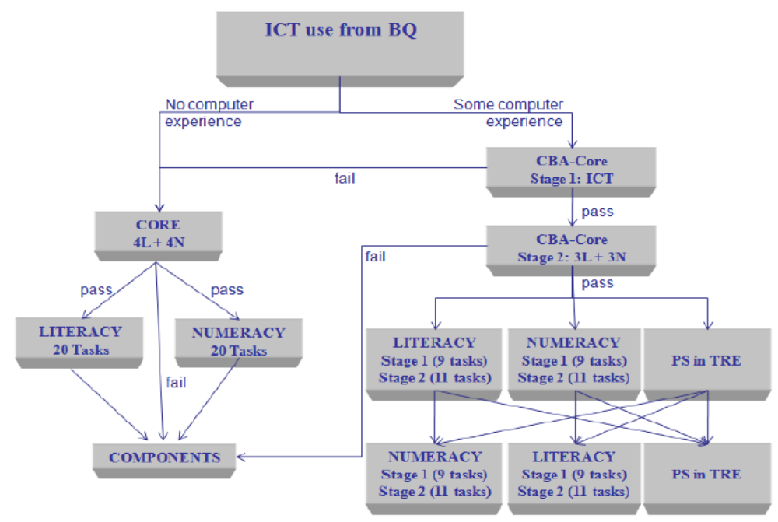
Source: OECD (2014: Figure 1.4).

Figure 2. Relationship between adult computational skills (Item A) and interpretive skills (Item C), by country
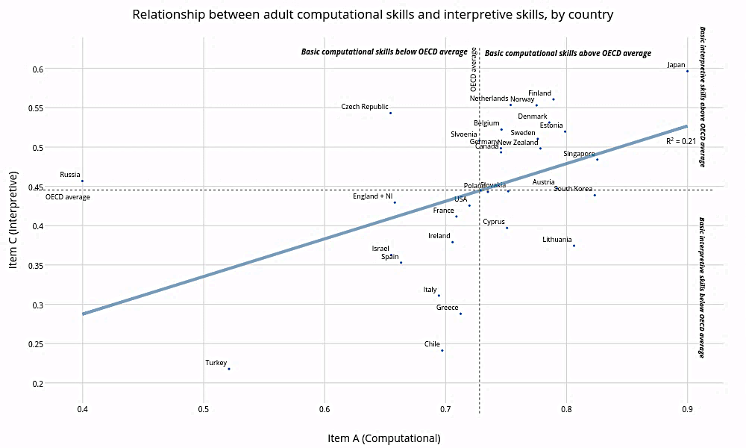

Notes: Authors’ calculations using the PIAAC database.

Figure 3. Average percentage correct by education level (low, medium, high) across Items A-D

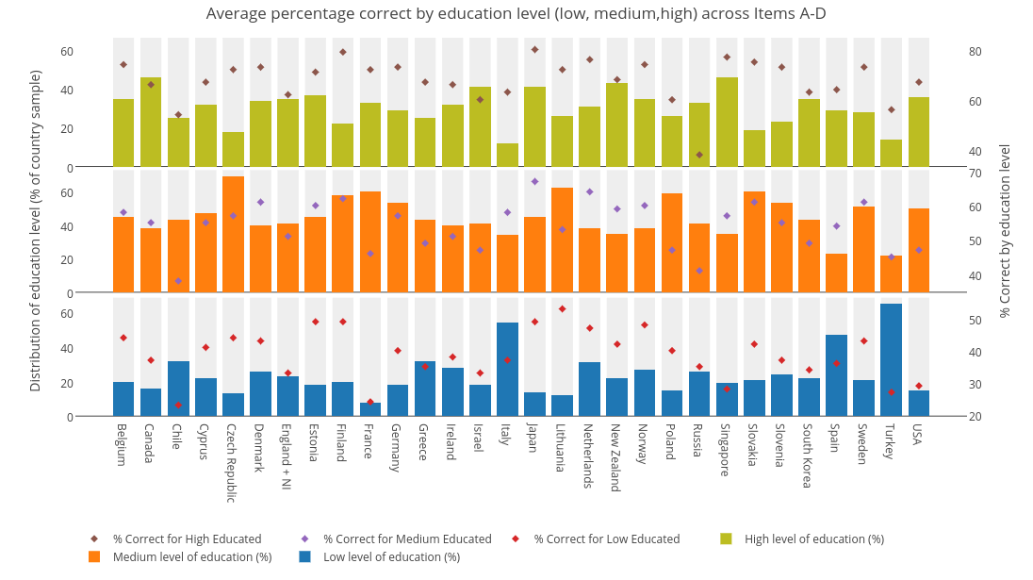
Notes: Authors’ calculations using the PIAAC database.
Figure 4. Percentage correct responses by age group: cross-country averages

Notes: Authors’ calculations using the PIAAC database. Figures refer to the average taken across all participating countries. Full set of country-by-country results can be made available upon request.

Figure 5. Percentage correct responses to item A by age group (selected countries)

Authors’ calculations using the PIAAC database. Figures refer to the percentage of adults who answered the question correctly, by age group. Full set of country-by-country results can be made available upon request.

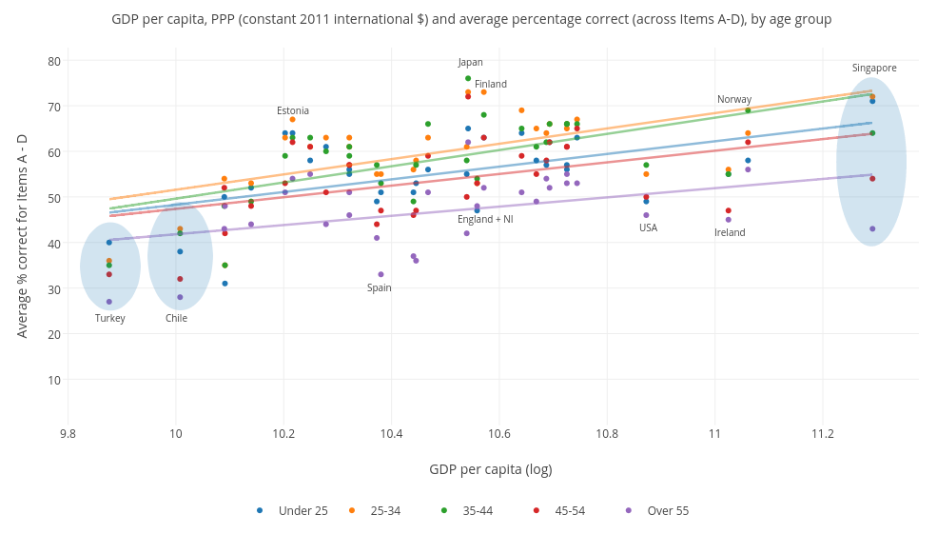
Figure 6. GDP per capita, PPP (constant 2011 international $) and average percentage correct (across Items A-D), by age group
Notes: Authors’ calculations using the PIAAC database. GDP per capita, PPP (constant 2011 international $) latest data from World Bank, World Development Indicators (Accessed June 21, 2017).
Table 1: The correlation between PISA 2012 mathematics scores and PIAAC financial items percentage correct for 16 to 24 year olds at the country level

 | All countries | Excluding Russia
Correlation PISA maths with Item A | 0.401 | 0.567
Correlation PISA maths with Item B | 0.295 | 0.306
Correlation PISA maths with Item C | 0.698 | 0.696
Correlation PISA maths with Item D | 0.583 | 0.581

Appendix A
- Item A (code = C602A502) Mock Question:
Suppose, upon your trip to the grocery store you purchase four types of tea packs: Chamomile Tea ($4.60), Green Tea ($4.15), Black Tea ($3.35) and Lemon Tea ($1.80). If you paid for all these items with a $20 bill, how much change would you get?
- Item B (code = C602A503) Mock Question:
Suppose, a litre of cola costs $3.15. If you buy one-third of a litre of cola, how much will you pay?
- Item C (code = C620A612). Mock Question:
Estimate the average unemployment rate for men over the 12-year period.
The U.S. Bureau of Labour Statistics monitors the unemployment rates in the U.S. for men and women. For example, the graph below is based on data collected by the Bureau and shows the unemployment rates for a period of 12 years between 1970 – 1981 for men and women.

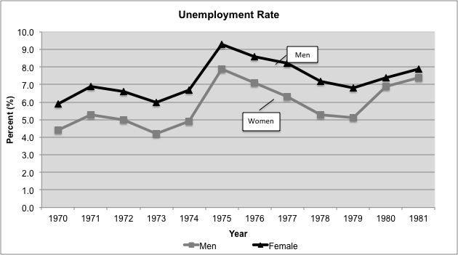

- Item D (code = C664P001). Mock Question:
The sales department of the Bristol football club wants to offer the same discount for a Stand 4 season ticket as is offered for the other season tickets. A single Stand 4 ticket price is $21. Using the same formula, what would the price be for a Stand 4 season ticket?
Bristol Football Club
Ticket Prices
Seating  Categories | Single Category | Season  (Entry to 8 matches)
Main Stand | $50 | $300
Stand 2 | $35 | $210
Stand 3 | $25 | $150
Stand 4 | $21

Appendix B
Table B1. Sample sizes and response rates by country
 | Response rate | Non-response bias | Computer test | Paper test
Turkey | 80 | Minimal | 2,266 | 2,926
Korea (KR) | 75 | Minimal | 4,540 | 2,111
Cyprus (CY) | 73 | Minimal | 2,247 | 2,144
Ireland (IE) | 72 | Minimal | 4,092 | 1,868
United States (US) | 70 | Low | 4,103 | 787
France (FR) | 67 | Minimal | 4,938 | 1,946
Czech Republic (CZ) | 66 | Low | 4,675 | 1,404
Finland (FI) | 66 | Minimal | 4,503 | 955
Slovak Republic (SK) | 66 | Low | 3,537 | 2,164
Chile | 66 | Minimal | 3,342 | 1,840
Estonia (EE) | 63 | Low | 5,235 | 2,342
New Zealand | 63 | Minimal | 5,510 | 548
Singapore | 63 | Minimal | 4,071 | 1,319
Slovenia | 62 | Minimal | 3,995 | 1,288
Belgium (BE) | 62 | Low | 4,186 | 795
Norway (NO) | 62 | Low | 4,342 | 605
Israel | 61 | Minimal | 3,598 | 1,672
Canada (CA) | 59 | Minimal | 21,189 | 5,195
England + NI (E+N) | 59 | Low | 7,322 | 1,475
Poland (PL) | 56 | Low | 5,992 | 3,372
Germany (DE) | 55 | Low | 4,541 | 835
Italy (IT) | 55 | Low | 2,823 | 1,763
Lithuania | 54 | Low | 3,677 | 1,371
Austria (AT) | 53 | Low | 3,855 | 1,169
Greece | 52 | Low | 2,453 | 1,430
Russia (RU) | 52 | Unknown | 2,851 | 1,041
Netherlands (NL) | 51 | Low | 4,548 | 534
Denmark (DK) | 50 | Low | 6,098 | 1,187
Japan (JP) | 50 | Low | 3,307 | 1,865
Spain (ES) | 48 | Low | 3,950 | 2,019
Sweden (SE) | 45 | Low | 3,963 | 502

Table B2. Inequality in performance on the financial PIAAC questions by educational attainment
 | Item A |  | Item B |  | Item C |  | Item D
 | Lower CI | Upper CI | Lower CI | Upper CI | Lower CI | Upper CI | Lower CI | Upper CI
France | 28% | 41% | 42% | 51% | 49% | 58% | 52% | 59%
Singapore | 29% | 40% | 52% | 62% | 50% | 63% | 43% | 54%
Slovenia | 26% | 39% | 27% | 44% | 29% | 46% | 33% | 47%
USA | 20% | 34% | 45% | 59% | 20% | 39% | 35% | 50%
Turkey | 20% | 33% | 24% | 35% | 19% | 33% | 23% | 41%
Chile | 17% | 36% | 32% | 54% | 20% | 44% | 13% | 30%
Greece | 16% | 31% | 19% | 35% | 27% | 47% | 32% | 49%
Spain | 19% | 27% | 22% | 29% | 25% | 33% | 29% | 37%
Germany | 15% | 31% | 33% | 45% | 19% | 37% | 34% | 51%
Israel | 16% | 29% | 22% | 32% | 18% | 35% | 26% | 37%
Canada | 18% | 26% | 30% | 38% | 25% | 32% | 29% | 38%
Slovakia | 13% | 29% | 21% | 36% | 22% | 41% | 39% | 57%
Ireland | 15% | 27% | 24% | 34% | 22% | 34% | 27% | 40%
Belgium | 14% | 28% | 24% | 34% | 27% | 42% | 33% | 46%
Denmark | 14% | 23% | 24% | 34% | 29% | 46% | 28% | 43%
Sweden | 10% | 26% | 24% | 39% | 21% | 39% | 32% | 50%
Poland | 9% | 24% | 18% | 28% | 26% | 40% | - | -
South Korea | 12% | 20% | 24% | 36% | 28% | 39% | 32% | 41%
Finland | 10% | 22% | 25% | 37% | 27% | 42% | 29% | 48%
Italy | 7% | 22% | 13% | 28% | 23% | 38% | 29% | 43%
England + NI | 7% | 21% | 29% | 37% | 22% | 34% | 33% | 46%
Norway | 9% | 18% | 21% | 33% | 24% | 37% | 29% | 40%
New Zealand | 7% | 19% | 24% | 38% | 18% | 32% | 28% | 42%
Japan | 8% | 17% | 23% | 35% | 29% | 43% | 43% | 54%
Cyprus | 5% | 19% | 21% | 32% | 28% | 41% | 25% | 35%
Netherlands | 7% | 17% | 21% | 32% | 35% | 46% | 28% | 43%
Czech Republic | -3% | 26% | 19% | 36% | 28% | 47% | 25% | 48%
Estonia | 5% | 17% | 16% | 24% | 21% | 31% | 23% | 38%
Lithuania | -1% | 14% | 15% | 34% | 20% | 42% | -3% | 31%
Russia | -18% | 4% | -14% | 6% | 2% | 17% | 3% | 24%
Notes: Authors’ calculations using the PIAAC database. Full results by education group for each country can be made available upon request. Figures refer to the difference between individuals with ‘low’ (completed lower-secondary education or less) and ‘high’ (completed tertiary education) levels of education. Red shading refers to a large gap between education groups relative to other countries, while green shading refers to a comparatively small gap.

Table B3. The performance of young people (age 16 to 25) on the PIAAC financial items
 | Item A |  | Item B |  | Item C |  | Item D
 | Lower CI | Upper CI | Lower CI | Upper CI | Lower CI | Upper CI | Lower CI | Upper CI
Lithuania | 85% | 93% | 69% | 82% | 37% | 51% | 42% | 57%
Singapore | 83% | 91% | 74% | 82% | 51% | 62% | 55% | 67%
South Korea | 83% | 90% | 36% | 47% | 39% | 50% | 34% | 46%
Japan | 82% | 90% | 59% | 70% | 47% | 59% | 50% | 60%
Estonia | 80% | 86% | 67% | 75% | 49% | 60% | 43% | 51%
Austria | 75% | 86% | 65% | 77% | 37% | 50% | 41% | 59%
Finland | 76% | 86% | 60% | 73% | 53% | 63% | 37% | 52%
Poland | 77% | 83% | 68% | 74% | 48% | 56% | - | -
Belgium | 76% | 83% | 64% | 75% | 48% | 61% | 47% | 59%
Sweden | 73% | 84% | 53% | 67% | 36% | 52% | 33% | 49%
Germany | 72% | 84% | 63% | 74% | 38% | 51% | 32% | 44%
Norway | 73% | 83% | 55% | 64% | 45% | 61% | 35% | 45%
Slovenia | 73% | 83% | 51% | 63% | 54% | 65% | 44% | 56%
Denmark | 73% | 83% | 53% | 66% | 40% | 59% | 33% | 44%
Greece | 72% | 84% | 67% | 80% | 13% | 29% | 17% | 36%
Netherlands | 72% | 82% | 63% | 80% | 46% | 59% | 45% | 55%
New Zealand | 72% | 82% | 52% | 62% | 44% | 59% | 35% | 44%
Cyprus | 72% | 82% | 60% | 71% | 36% | 51% | 27% | 43%
Ireland | 70% | 82% | 56% | 66% | 34% | 47% | 30% | 51%
France | 70% | 79% | 59% | 67% | 42% | 52% | 30% | 39%
Canada | 71% | 78% | 52% | 62% | 47% | 57% | 45% | 54%
Italy | 67% | 78% | 57% | 69% | 31% | 48% | 19% | 36%
Chile | 65% | 80% | 33% | 48% | 16% | 36% | 8% | 20%
Spain | 69% | 76% | 55% | 63% | 30% | 42% | 31% | 42%
Slovakia | 66% | 78% | 67% | 79% | 37% | 49% | 35% | 50%
USA | 64% | 78% | 40% | 54% | 36% | 55% | 23% | 39%
England + NI | 59% | 73% | 46% | 61% | 30% | 45% | 22% | 41%
Czech Republic | 58% | 71% | 50% | 64% | 53% | 66% | 36% | 51%
Israel | 59% | 69% | 47% | 57% | 34% | 41% | 34% | 45%
Turkey | 54% | 66% | 46% | 58% | 23% | 34% | 13% | 27%
Russia | 17% | 33% | 17% | 31% | 33% | 47% | 24% | 47%
Notes: Authors’ calculations using the PIAAC database. Green shading refers to strong performance compared to other countries, while red shading refers to weak performance. Full results for all age groups can be made available upon request.

Figure B1. Gender differences for Item A, by age group
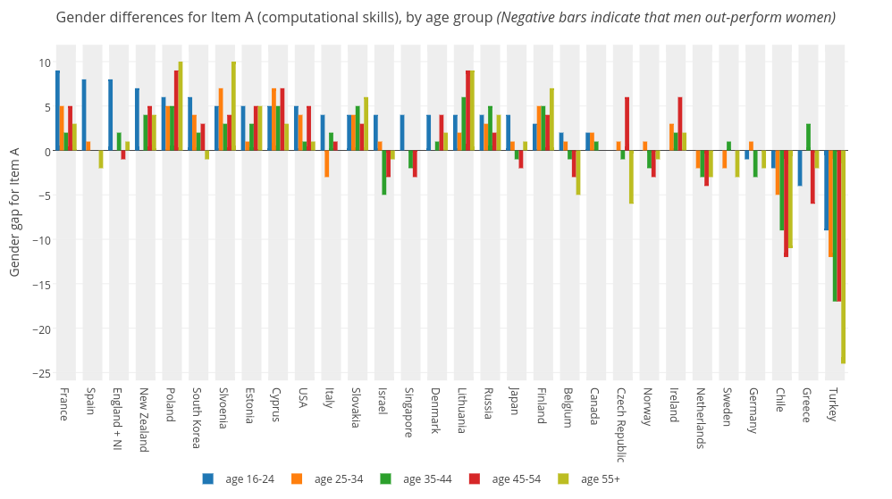
(Negative bars indicate that men out-perform women)

Figure B2. Gender differences for Item C, by age group
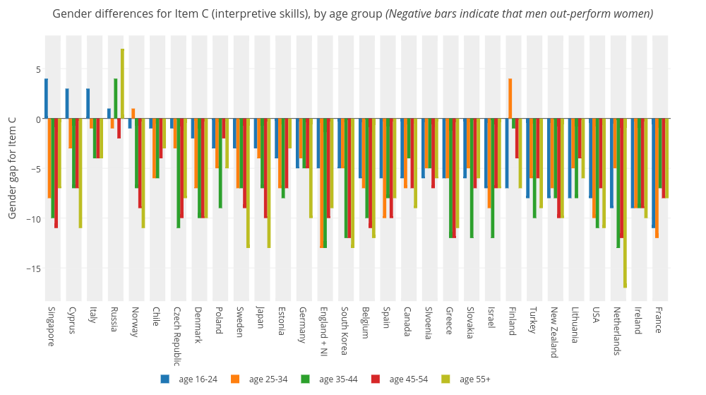
(Negative bars indicate that men out-perform women)
Appendix C. Correlations between the multiple imputation and complete case results
Appendix Figure C1. Percentage correct rankings
- Percentage correct rankings. Item A.
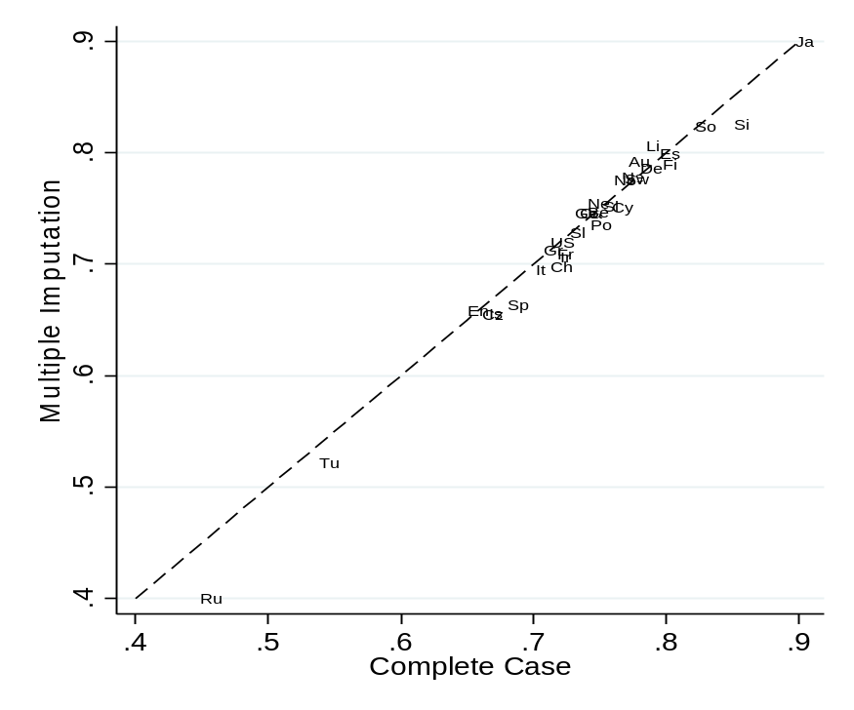

Percentage correct rankings. Item B.
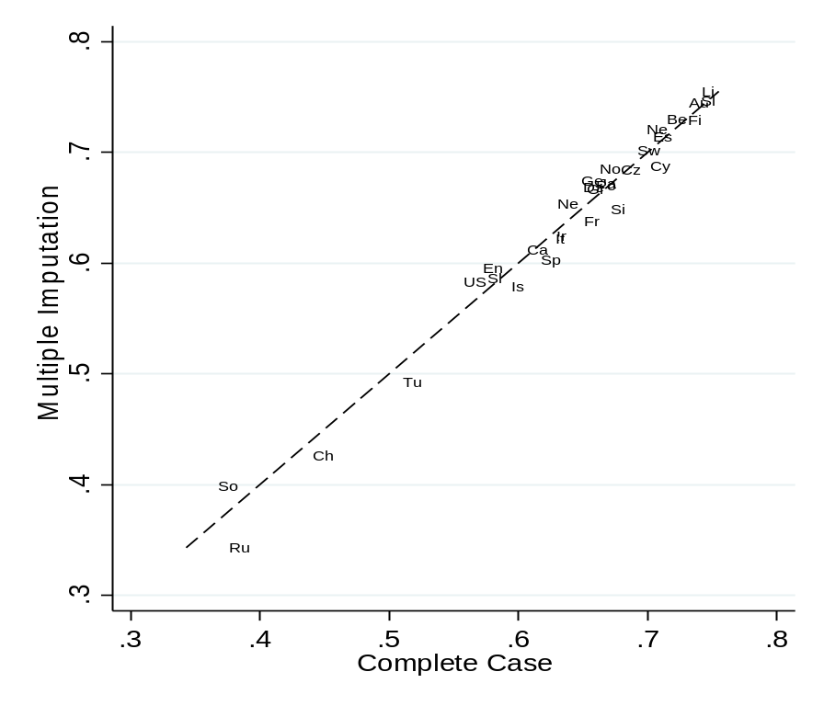
Percentage correct rankings. Item C.
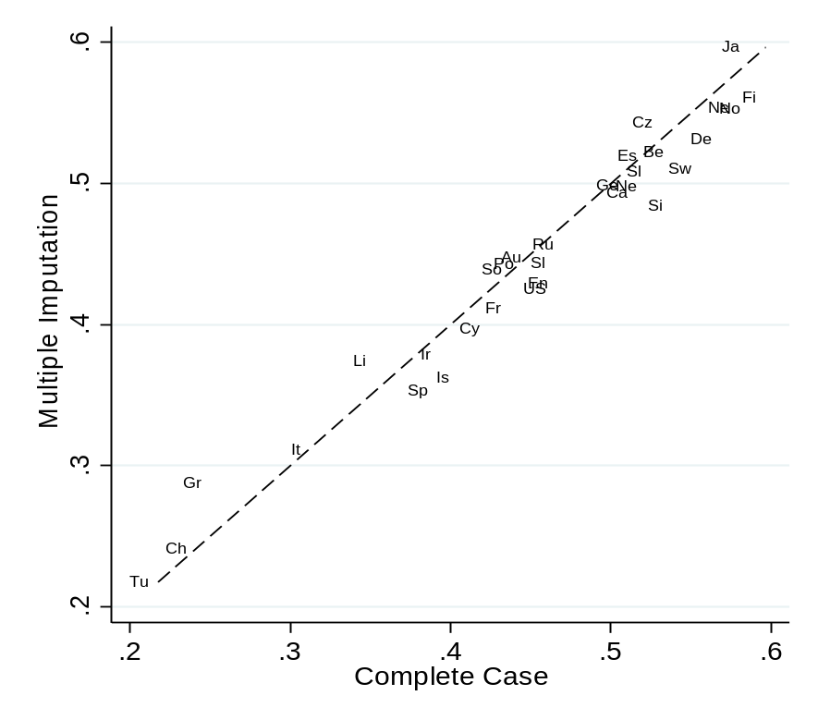

Percentage correct rankings. Item D.
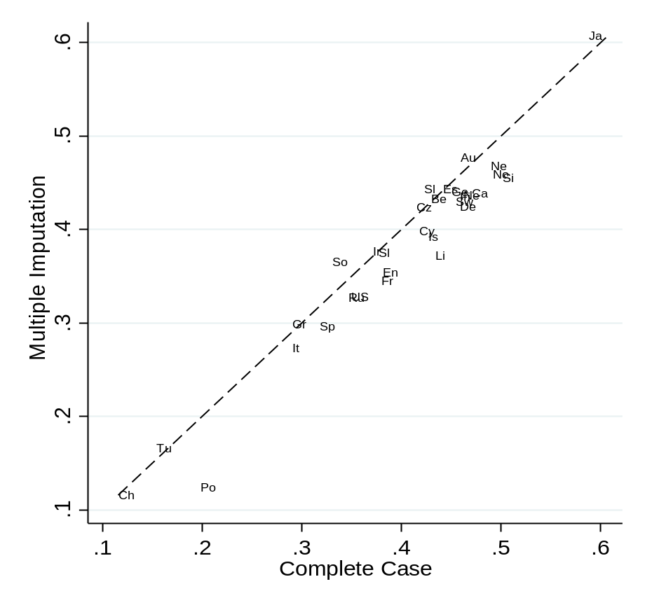
Appendix D. The distribution of education levels and occupational group across countries
- Education level
 | Low % | Medium % | High % | Total %
Belgium | 20 | 45 | 35 | 100
Canada | 16 | 38 | 46 | 100
Chile | 32 | 43 | 25 | 100
Cyprus | 22 | 47 | 32 | 100
Czech Republic | 13 | 69 | 18 | 100
Denmark | 26 | 40 | 34 | 100
England + NI | 23 | 41 | 35 | 100
Estonia | 18 | 45 | 37 | 100
Finland | 20 | 58 | 22 | 100
France | 8 | 60 | 33 | 100
Germany | 18 | 53 | 29 | 100
Greece | 32 | 43 | 25 | 100
Ireland | 28 | 40 | 32 | 100
Israel | 18 | 41 | 41 | 100
Italy | 54 | 34 | 12 | 100
Japan | 14 | 45 | 41 | 100
Lithuania | 12 | 62 | 26 | 100
Netherlands | 31 | 38 | 31 | 100
New Zealand | 22 | 35 | 43 | 100
Norway | 27 | 38 | 35 | 100
Poland | 15 | 59 | 26 | 100
Russia | 26 | 41 | 33 | 100
Singapore | 19 | 35 | 46 | 100
Slovakia | 21 | 60 | 19 | 100
Slovenia | 24 | 53 | 23 | 100
South Korea | 22 | 43 | 35 | 100
Spain | 47 | 23 | 29 | 100
Sweden | 21 | 51 | 28 | 100
Turkey | 65 | 22 | 14 | 100
USA | 15 | 50 | 36 | 100
International mean | 24 | 45 | 31 | 100
International median | 21 | 43 | 32 | 100

- Occupational group
 | Skilled % | Semi-skilled (white) % | Semi-skilled (blue) % | Elementary % | Not worked for 5 years % | Missing %
Austria | 34 | 24 | 19 | 8 | 12 | 3
Belgium | 35 | 20 | 14 | 7 | 18 | 7
Canada | 45 | 23 | 15 | 7 | 9 | 1
Chile | 20 | 27 | 21 | 15 | 15 | 1
Cyprus | 23 | 23 | 10 | 5 | 19 | 20
Czech Republic | 28 | 20 | 27 | 7 | 16 | 1
Denmark | 38 | 25 | 16 | 11 | 8 | 2
England + NI | 31 | 30 | 13 | 9 | 14 | 3
Estonia | 36 | 17 | 25 | 9 | 12 | 1
Finland | 34 | 25 | 21 | 8 | 11 | 1
France | 31 | 21 | 19 | 9 | 18 | 2
Germany | 31 | 26 | 20 | 8 | 13 | 3
Greece | 20 | 25 | 16 | 7 | 29 | 3
Ireland | 28 | 27 | 18 | 8 | 19 | 1
Israel | 40 | 22 | 11 | 4 | 16 | 7
Italy | 21 | 21 | 20 | 8 | 28 | 1
Japan | 27 | 30 | 16 | 5 | 14 | 8
Lithuania | 28 | 15 | 24 | 11 | 18 | 5
Netherlands | 43 | 25 | 10 | 8 | 12 | 3
New Zealand | 43 | 23 | 15 | 7 | 9 | 2
Norway | 35 | 27 | 13 | 4 | 9 | 11
Poland | 27 | 18 | 24 | 7 | 23 | 1
Russia | 30 | 16 | 20 | 4 | 15 | 15
Singapore | 46 | 24 | 8 | 5 | 14 | 3
Slovakia | 30 | 17 | 22 | 7 | 23 | 1
Slovenia | 30 | 15 | 22 | 5 | 26 | 2
South Korea | 22 | 32 | 17 | 9 | 19 | 1
Spain | 24 | 27 | 17 | 13 | 18 | 1
Sweden | 38 | 27 | 18 | 6 | 10 | 1
Turkey | 15 | 17 | 15 | 6 | 44 | 3
USA | 37 | 26 | 14 | 8 | 10 | 5
International mean | 31 | 23 | 17 | 8 | 17 | 4
International median | 31 | 24 | 17 | 7 | 15 | 2

Appendix E. The percentage of adults with a low level of education (lower secondary education or less) who answer each question correctly
 | Item A | Item B | Item C | Item D
France | 46% | 35% | 9% | 5%
Singapore | 58% | 25% | 13% | 15%
Slovenia | 55% | 40% | 34% | 18%
USA | 55% | 26% | 25% | 9%
Turkey | 43% | 41% | 15% | 9%
Chile | 55% | 23% | 12% | 2%
Greece | 61% | 54% | 12% | 13%
Spain | 56% | 49% | 22% | 16%
Germany | 60% | 44% | 35% | 21%
Israel | 50% | 40% | 21% | 21%
Canada | 59% | 37% | 30% | 21%
Slovakia | 62% | 58% | 27% | 22%
Ireland | 59% | 47% | 24% | 22%
Belgium | 62% | 55% | 32% | 25%
Denmark | 66% | 51% | 31% | 23%
Sweden | 65% | 53% | 35% | 20%
Poland | 66% | 57% | 31% | 6%
South Korea | 71% | 25% | 25% | 15%
Finland | 70% | 56% | 42% | 29%
Italy | 62% | 53% | 19% | 15%
England + NI | 56% | 38% | 25% | 14%
Norway | 69% | 54% | 39% | 29%
New Zealand | 68% | 45% | 36% | 20%
Japan | 81% | 48% | 38% | 27%
Cyprus | 66% | 53% | 21% | 24%
Netherlands | 67% | 56% | 36% | 29%
Czech Republic | 55% | 54% | 39% | 27%
Estonia | 72% | 59% | 36% | 28%
Lithuania | 79% | 62% | 29% | 43%
Russia | 42% | 36% | 39% | 23%

Appendix F: OLS regression results for Items A-D
- OLS regression results Item A
 | Gender (Ref: Female) |  | Age (Ref: 16 to 24) |  |  |  |  |  |  |  | Education (Ref: Low)
 | Beta | SE | Age_25_34 | SE | Age_35_44 | SE | Age_45_54 | SE | Age_55_Plus | SE | Medium | SE | High | SE | Constant
Belgium | -0.02 | 0.02 | -0.05 | 0.04 | -0.04 | 0.04 | -0.11* | 0.02 | -0.14* | 0.03 | 0.12* | 0.03 | 0.20* | 0.04 | 0.70
Canada | 0.00 | 0.02 | 0.00 | 0.02 | -0.03 | 0.02 | -0.06* | 0.02 | -0.13* | 0.03 | 0.14* | 0.03 | 0.21* | 0.03 | 0.63
Chile | -0.07* | 0.03 | -0.01 | 0.05 | 0.03 | 0.06 | -0.08 | 0.06 | -0.18* | 0.05 | 0.18* | 0.05 | 0.23* | 0.05 | 0.63
Cyprus | 0.06* | 0.02 | -0.04 | 0.04 | 0.00 | 0.04 | -0.04 | 0.04 | -0.07 | 0.04 | 0.09* | 0.03 | 0.11* | 0.03 | 0.67
Czech Republic | 0.00 | 0.03 | -0.02 | 0.05 | 0.00 | 0.05 | 0.00 | 0.04 | -0.05 | 0.05 | 0.12* | 0.06 | 0.17* | 0.07 | 0.57
Denmark | 0.02 | 0.02 | -0.03 | 0.03 | -0.01 | 0.03 | -0.05 | 0.03 | -0.15 | 0.03 | 0.16* | 0.03 | 0.19* | 0.02 | 0.70
Estonia | 0.03 | 0.02 | -0.05* | 0.02 | -0.06* | 0.03 | -0.10* | 0.02 | -0.12* | 0.02 | 0.10* | 0.03 | 0.14* | 0.03 | 0.76
Finland | 0.04* | 0.02 | -0.02 | 0.04 | -0.04 | 0.04 | -0.09 | 0.05 | -0.11 | 0.04 | 0.11* | 0.03 | 0.15* | 0.04 | 0.73
France | 0.04* | 0.01 | 0.01 | 0.03 | 0.00 | 0.04 | -0.03 | 0.03 | -0.09 | 0.03 | 0.18* | 0.03 | 0.29* | 0.04 | 0.51
Germany | 0.00 | 0.02 | -0.11* | 0.04 | -0.18* | 0.04 | -0.17* | 0.04 | -0.20* | 0.04 | 0.20* | 0.04 | 0.31* | 0.05 | 0.69
Greece | -0.02 | 0.03 | -0.11* | 0.04 | -0.16* | 0.05 | -0.01 | 0.04 | -0.12 | 0.05 | 0.10* | 0.03 | 0.25* | 0.04 | 0.70
Ireland | 0.01 | 0.02 | -0.03 | 0.04 | -0.09* | 0.04 | -0.14* | 0.04 | -0.09* | 0.04 | 0.12* | 0.03 | 0.20* | 0.03 | 0.66
Israel | -0.02 | 0.03 | 0.01 | 0.03 | -0.02 | 0.04 | -0.12* | 0.05 | -0.09* | 0.04 | 0.15* | 0.04 | 0.23* | 0.03 | 0.54
Italy | 0.00 | 0.03 | -0.01 | 0.04 | -0.04 | 0.04 | -0.06 | 0.04 | -0.09* | 0.04 | 0.15* | 0.02 | 0.14* | 0.04 | 0.67
Japan | 0.00 | 0.01 | 0.04 | 0.03 | 0.03 | 0.03 | 0.01 | 0.03 | 0.01 | 0.02 | 0.09* | 0.03 | 0.11* | 0.02 | 0.79
South Korea | 0.04* | 0.02 | -0.05 | 0.03 | -0.05 | 0.03 | -0.08* | 0.02 | -0.12* | 0.04 | 0.11* | 0.03 | 0.15* | 0.03 | 0.76
Lithuania | 0.05* | 0.02 | -0.08* | 0.04 | -0.11* | 0.03 | -0.14* | 0.04 | -0.21* | 0.03 | 0.07 | 0.04 | 0.12* | 0.05 | 0.81
Netherlands | -0.02 | 0.03 | -0.04 | 0.04 | -0.01 | 0.04 | -0.01 | 0.03 | -0.09 | 0.04 | 0.12* | 0.02 | 0.11* | 0.02 | 0.71
New Zealand | 0.04* | 0.02 | -0.01 | 0.04 | 0.08* | 0.04 | 0.01 | 0.04 | -0.08* | 0.04 | 0.11* | 0.03 | 0.12* | 0.03 | 0.67
Norway | -0.01 | 0.02 | -0.06 | 0.04 | -0.02 | 0.03 | -0.07* | 0.03 | -0.05 | 0.04 | 0.10* | 0.02 | 0.15* | 0.02 | 0.74
Poland | 0.06* | 0.02 | -0.11* | 0.03 | -0.09* | 0.02 | -0.11* | 0.02 | -0.18* | 0.02 | 0.08* | 0.04 | 0.18* | 0.04 | 0.71
Russia | 0.04 | 0.03 | 0.10 | 0.05 | 0.10* | 0.05 | 0.26* | 0.06 | 0.35* | 0.07 | -0.04 | 0.04 | -0.10* | 0.05 | 0.26
Singapore | 0.00 | 0.02 | -0.01 | 0.02 | 0.00 | 0.02 | -0.09* | 0.03 | -0.10* | 0.02 | 0.22* | 0.04 | 0.31* | 0.03 | 0.65
Slovakia | 0.05 | 0.03 | -0.05 | 0.04 | 0.01 | 0.04 | 0.03 | 0.04 | -0.01 | 0.04 | 0.15* | 0.03 | 0.22* | 0.04 | 0.60
Slovenia | 0.05* | 0.02 | -0.08* | 0.03 | -0.08* | 0.04 | -0.13* | 0.03 | -0.23* | 0.03 | 0.19* | 0.03 | 0.32* | 0.03 | 0.65
Spain | 0.00 | 0.02 | -0.02 | 0.03 | -0.05 | 0.02 | -0.09* | 0.03 | -0.23* | 0.03 | 0.14* | 0.02 | 0.20* | 0.02 | 0.65
Sweden | -0.02 | 0.03 | -0.04 | 0.04 | -0.03 | 0.04 | -0.04 | 0.05 | -0.12* | 0.04 | 0.16* | 0.03 | 0.19* | 0.04 | 0.70
Turkey | -0.12* | 0.03 | -0.11* | 0.04 | -0.02 | 0.04 | -0.09 | 0.05 | -0.14* | 0.05 | 0.21* | 0.03 | 0.25* | 0.03 | 0.56
England + NI | 0.02 | 0.04 | 0.00 | 0.05 | -0.01 | 0.05 | 0.04 | 0.04 | -0.05 | 0.05 | 0.11* | 0.03 | 0.14* | 0.04 | 0.56
USA | 0.03 | 0.02 | -0.06 | 0.05 | 0.00 | 0.05 | -0.08 | 0.05 | -0.12* | 0.05 | 0.17* | 0.03 | 0.29* | 0.04 | 0.57
Average | 0.01 |  | -0.03 |  | -0.03 |  | -0.05 |  | -0.10 |  | 0.13 |  | 0.19 |  | 0.65
* Denotes significance at the 5%-level.

- OLS regression results Item B
 | Gender (Ref: Female) |  | Age (Ref: 16 to 24) |  |  |  |  |  |  |  | Education (Ref: Low)
 | Beta | SE | Age_25_34 | SE | Age_35_44 | SE | Age_45_54 | SE | Age_55_Plus | SE | Medium | SE | High | SE | Constant
Belgium | -0.07* | 0.02 | 0.01 | 0.04 | -0.05 | 0.04 | -0.01 | 0.04 | -0.02 | 0.03 | 0.16* | 0.03 | 0.29* | 0.04 | 0.60
Canada | -0.10* | 0.02 | -0.07* | 0.03 | -0.05 | 0.03 | -0.07* | 0.03 | -0.08* | 0.03 | 0.22* | 0.02 | 0.35* | 0.02 | 0.48
Chile | -0.07* | 0.03 | -0.03 | 0.03 | 0.06 | 0.05 | -0.03 | 0.06 | -0.10 | 0.05 | 0.20* | 0.03 | 0.43* | 0.04 | 0.29
Cyprus | 0.01 | 0.02 | 0.00 | 0.04 | 0.00 | 0.04 | 0.03 | 0.04 | -0.03 | 0.04 | 0.14* | 0.03 | 0.25* | 0.03 | 0.55
Czech Republic | 0.01 | 0.03 | 0.10 | 0.06 | 0.10 | 0.08 | 0.08 | 0.05 | 0.13* | 0.05 | 0.10* | 0.05 | 0.24* | 0.04 | 0.48
Denmark | -0.02 | 0.02 | 0.00 | 0.04 | -0.01 | 0.05 | 0.00 | 0.04 | -0.06 | 0.03 | 0.16* | 0.03 | 0.29* | 0.02 | 0.53
Estonia | -0.02 | 0.02 | -0.05* | 0.03 | -0.04 | 0.03 | -0.05 | 0.03 | -0.12* | 0.03 | 0.13* | 0.02 | 0.23* | 0.02 | 0.64
Finland | -0.04 | 0.02 | 0.02 | 0.05 | -0.02 | 0.04 | 0.01 | 0.04 | -0.04 | 0.04 | 0.17* | 0.02 | 0.30* | 0.03 | 0.59
France | -0.03 | 0.02 | 0.01 | 0.03 | 0.02 | 0.02 | 0.03 | 0.03 | 0.07 | 0.03 | 0.25* | 0.03 | 0.50* | 0.02 | 0.31
Germany | -0.09* | 0.02 | -0.18* | 0.04 | -0.21* | 0.03 | -0.17* | 0.04 | -0.23* | 0.03 | 0.30* | 0.03 | 0.46* | 0.04 | 0.60
Greece | 0.00 | 0.02 | -0.10* | 0.05 | -0.16* | 0.05 | -0.06 | 0.05 | -0.10* | 0.05 | 0.13* | 0.04 | 0.28* | 0.04 | 0.63
Ireland | -0.05* | 0.03 | -0.01 | 0.04 | 0.03 | 0.04 | -0.05 | 0.04 | -0.02 | 0.04 | 0.16* | 0.03 | 0.29* | 0.03 | 0.51
Israel | -0.12* | 0.03 | 0.04 | 0.04 | 0.02 | 0.04 | -0.08 | 0.06 | -0.04 | 0.04 | 0.17* | 0.03 | 0.28* | 0.03 | 0.46
Italy | -0.04 | 0.02 | -0.03 | 0.04 | 0.00 | 0.04 | -0.01 | 0.04 | -0.07 | 0.04 | 0.18* | 0.03 | 0.21* | 0.04 | 0.58
Japan | -0.02 | 0.02 | -0.01 | 0.04 | 0.02 | 0.05 | -0.04 | 0.03 | -0.10* | 0.03 | 0.16* | 0.04 | 0.28* | 0.03 | 0.53
South Korea | -0.04* | 0.02 | -0.07 | 0.04 | -0.05 | 0.03 | -0.12* | 0.04 | -0.14* | 0.03 | 0.08* | 0.03 | 0.28* | 0.03 | 0.36
Lithuania | 0.01 | 0.02 | -0.08* | 0.04 | 0.00 | 0.04 | -0.12* | 0.04 | -0.05 | 0.04 | 0.14* | 0.05 | 0.28* | 0.05 | 0.64
Netherlands | -0.09* | 0.02 | -0.03 | 0.04 | 0.00 | 0.05 | 0.00 | 0.04 | -0.11* | 0.05 | 0.18* | 0.03 | 0.26* | 0.03 | 0.65
New Zealand | -0.01 | 0.02 | 0.04 | 0.04 | 0.09* | 0.03 | 0.07* | 0.04 | 0.01 | 0.03 | 0.19* | 0.03 | 0.30* | 0.04 | 0.42
Norway | 0.00 | 0.02 | 0.00 | 0.03 | 0.04 | 0.03 | 0.05 | 0.03 | 0.00 | 0.04 | 0.13* | 0.04 | 0.26* | 0.03 | 0.53
Poland | 0.02 | 0.02 | -0.06* | 0.03 | -0.08* | 0.04 | -0.09* | 0.03 | -0.16* | 0.03 | 0.09* | 0.03 | 0.24* | 0.03 | 0.62
Russia | 0.01 | 0.04 | 0.06 | 0.06 | 0.07 | 0.05 | 0.11* | 0.05 | 0.34* | 0.05 | -0.04 | 0.05 | -0.05 | 0.05 | 0.26
Singapore | -0.01 | 0.02 | -0.16* | 0.03 | -0.18* | 0.03 | -0.16* | 0.03 | -0.19* | 0.03 | 0.33* | 0.03 | 0.56* | 0.03 | 0.43
Slovakia | 0.02 | 0.02 | -0.07 | 0.04 | -0.05 | 0.04 | -0.02 | 0.04 | -0.03 | 0.04 | 0.20* | 0.03 | 0.30* | 0.04 | 0.59
Slovenia | -0.01 | 0.02 | -0.06 | 0.04 | -0.06 | 0.04 | -0.07 | 0.05 | -0.10* | 0.05 | 0.21* | 0.03 | 0.36* | 0.05 | 0.46
Spain | -0.02 | 0.02 | 0.02 | 0.03 | 0.02 | 0.03 | -0.02 | 0.03 | -0.10* | 0.03 | 0.15* | 0.02 | 0.24* | 0.02 | 0.53
Sweden | -0.08* | 0.02 | 0.04 | 0.05 | 0.06 | 0.05 | 0.03 | 0.04 | 0.06 | 0.04 | 0.16* | 0.04 | 0.31* | 0.04 | 0.53
Turkey | -0.09* | 0.03 | -0.04 | 0.03 | 0.02 | 0.05 | -0.03 | 0.04 | -0.05 | 0.05 | 0.17* | 0.04 | 0.28* | 0.03 | 0.48
England + NI | -0.04 | 0.02 | 0.02 | 0.05 | 0.07 | 0.05 | 0.06 | 0.05 | 0.09 | 0.05 | 0.24* | 0.03 | 0.33* | 0.02 | 0.35
USA | -0.09* | 0.02 | -0.01 | 0.05 | 0.04 | 0.06 | 0.00 | 0.05 | -0.01 | 0.04 | 0.27* | 0.04 | 0.53* | 0.04 | 0.30
Average | -0.04 |  | -0.02 |  | -0.01 |  | -0.02 |  | -0.04 |  | 0.17 |  | 0.30 |  | 0.50
* Denotes significance at the 5%-level.
- OLS regression results Item C

 | Gender (Ref: Female) |  | Age (Ref: 16 to 24) |  |  |  |  |  |  |  | Education (Ref: Low)
 | Beta | SE | Age_25_34 | SE | Age_35_44 | SE | Age_45_54 | SE | Age_55_Plus | SE | Medium | SE | High | SE | Constant
Belgium | -0.10* | 0.03 | -0.05 | 0.06 | -0.02 | 0.05 | -0.11* | 0.05 | -0.16* | 0.04 | 0.16* | 0.04 | 0.35* | 0.05 | 0.46
Canada | -0.07* | 0.02 | -0.03 | 0.04 | -0.12* | 0.03 | -0.13* | 0.04 | -0.18* | 0.03 | 0.16* | 0.03 | 0.30* | 0.02 | 0.43
Chile | -0.05 | 0.05 | -0.08 | 0.06 | -0.04 | 0.07 | -0.13* | 0.06 | -0.06 | 0.07 | 0.10* | 0.04 | 0.33* | 0.06 | 0.19
Cyprus | -0.05* | 0.03 | -0.10* | 0.05 | -0.10* | 0.04 | -0.08 | 0.04 | -0.13* | 0.04 | 0.17* | 0.04 | 0.37* | 0.03 | 0.31
Czech Republic | -0.06 | 0.03 | -0.12 | 0.08 | -0.15 | 0.08 | -0.10 | 0.08 | -0.24* | 0.06 | 0.16* | 0.06 | 0.39* | 0.06 | 0.54
Denmark | -0.09* | 0.03 | -0.12* | 0.06 | -0.11* | 0.05 | -0.09 | 0.05 | -0.15* | 0.05 | 0.25* | 0.03 | 0.42* | 0.04 | 0.43
Estonia | -0.09* | 0.02 | -0.02 | 0.04 | -0.13* | 0.03 | -0.13* | 0.04 | -0.23* | 0.04 | 0.17* | 0.03 | 0.32* | 0.03 | 0.48
Finland | -0.05 | 0.03 | -0.06 | 0.04 | -0.09* | 0.05 | -0.09* | 0.04 | -0.21* | 0.04 | 0.12* | 0.04 | 0.36* | 0.04 | 0.54
France | -0.11* | 0.02 | 0.00 | 0.03 | -0.02 | 0.02 | -0.05 | 0.03 | -0.13* | 0.03 | 0.18* | 0.02 | 0.47* | 0.03 | 0.25
Germany | -0.04 | 0.03 | -0.09* | 0.05 | -0.04 | 0.04 | -0.16* | 0.05 | -0.12* | 0.04 | 0.18* | 0.03 | 0.36* | 0.05 | 0.40
Greece | -0.10* | 0.03 | 0.04 | 0.05 | 0.09 | 0.04 | 0.09* | 0.05 | 0.02 | 0.05 | 0.17* | 0.03 | 0.36* | 0.05 | 0.13
Ireland | -0.11* | 0.03 | -0.06 | 0.04 | -0.05 | 0.04 | -0.06 | 0.05 | -0.09 | 0.05 | 0.11* | 0.03 | 0.29* | 0.03 | 0.35
Israel | -0.11* | 0.03 | -0.11* | 0.04 | -0.04 | 0.04 | -0.16* | 0.04 | -0.24* | 0.03 | 0.12* | 0.03 | 0.32* | 0.04 | 0.34
Italy | -0.03 | 0.03 | -0.05 | 0.05 | -0.11* | 0.05 | -0.14* | 0.05 | -0.20* | 0.05 | 0.22* | 0.03 | 0.29* | 0.04 | 0.33
Japan | -0.08* | 0.02 | 0.02 | 0.04 | 0.04 | 0.04 | 0.01 | 0.05 | -0.06 | 0.05 | 0.15* | 0.04 | 0.34* | 0.04 | 0.43
South Korea | -0.08* | 0.03 | -0.04 | 0.05 | -0.01 | 0.05 | -0.10* | 0.03 | -0.18* | 0.05 | 0.11* | 0.03 | 0.28* | 0.04 | 0.40
Lithuania | -0.09* | 0.03 | -0.09 | 0.05 | -0.14* | 0.05 | -0.16* | 0.04 | -0.19* | 0.05 | 0.08 | 0.04 | 0.39* | 0.06 | 0.39
Netherlands | -0.11* | 0.02 | -0.02 | 0.05 | -0.07 | 0.04 | 0.01 | 0.04 | -0.10* | 0.04 | 0.17* | 0.04 | 0.40* | 0.03 | 0.45
New Zealand | -0.09* | 0.03 | -0.05 | 0.03 | -0.04 | 0.05 | -0.08 | 0.05 | -0.16* | 0.05 | 0.08* | 0.03 | 0.25* | 0.04 | 0.47
Norway | -0.06* | 0.03 | -0.07 | 0.05 | -0.04 | 0.04 | -0.06 | 0.05 | -0.16* | 0.04 | 0.15* | 0.03 | 0.32* | 0.03 | 0.48
Poland | -0.07* | 0.02 | -0.09* | 0.04 | -0.18* | 0.04 | -0.17* | 0.03 | -0.22* | 0.03 | 0.12* | 0.03 | 0.37* | 0.03 | 0.44
Russia | 0.01 | 0.06 | 0.07 | 0.08 | 0.05 | 0.06 | 0.00 | 0.05 | 0.04 | 0.04 | 0.08* | 0.04 | 0.08 | 0.05 | 0.36
Singapore | -0.05 | 0.04 | -0.09* | 0.04 | -0.19* | 0.03 | -0.13* | 0.04 | -0.18* | 0.03 | 0.22* | 0.04 | 0.54* | 0.04 | 0.30
Slovakia | -0.07* | 0.02 | -0.05 | 0.03 | -0.05 | 0.04 | -0.01 | 0.04 | -0.07 | 0.05 | 0.18* | 0.03 | 0.33* | 0.05 | 0.34
Slovenia | -0.09* | 0.03 | -0.14* | 0.05 | -0.16* | 0.04 | -0.24* | 0.04 | -0.25* | 0.04 | 0.16* | 0.03 | 0.40* | 0.05 | 0.54
Spain | -0.10* | 0.02 | -0.01 | 0.04 | 0.00 | 0.04 | -0.04 | 0.04 | -0.14* | 0.04 | 0.17* | 0.03 | 0.28* | 0.02 | 0.32
Sweden | -0.10* | 0.03 | 0.05 | 0.05 | 0.03 | 0.05 | 0.03 | 0.05 | -0.07 | 0.05 | 0.14* | 0.03 | 0.29* | 0.04 | 0.40
Turkey | -0.05 | 0.03 | -0.07 | 0.04 | -0.09* | 0.04 | -0.05 | 0.05 | -0.12* | 0.04 | 0.13* | 0.03 | 0.25* | 0.04 | 0.24
England + NI | -0.10* | 0.02 | 0.06 | 0.04 | 0.06 | 0.04 | 0.06 | 0.05 | 0.03 | 0.03 | 0.18* | 0.03 | 0.27* | 0.03 | 0.26
USA | -0.10* | 0.03 | -0.08 | 0.07 | -0.07 | 0.06 | -0.16* | 0.07 | -0.16* | 0.06 | 0.17* | 0.04 | 0.34* | 0.05 | 0.37
Average | -0.08 |  | -0.05 |  | -0.06 |  | -0.08 |  | -0.14 |  | 0.15 |  | 0.34 |  | 0.38
* Denotes significance at the 5%-level.

- OLS regression results Item D
 | Gender (Ref: Female) |  | Age (Ref: 16 to 24) |  |  |  |  |  |  |  | Education (Ref: Low)
 | Beta | SE | Age_25_34 | SE | Age_35_44 | SE | Age_45_54 | SE | Age_55_Plus | SE | Medium | SE | High | SE | Constant
Belgium | -0.19* | 0.02 | -0.07 | 0.04 | -0.17* | 0.03 | -0.19* | 0.04 | -0.29* | 0.03 | 0.08* | 0.03 | 0.39* | 0.03 | 0.52
Canada | -0.07* | 0.02 | -0.06 | 0.04 | -0.13* | 0.02 | -0.19* | 0.02 | -0.25* | 0.03 | 0.19* | 0.02 | 0.34* | 0.03 | 0.37
Chile | -0.09* | 0.02 | 0.01 | 0.04 | -0.06* | 0.03 | -0.05 | 0.03 | -0.07 | 0.04 | 0.09* | 0.02 | 0.21* | 0.03 | 0.10
Cyprus | -0.06* | 0.03 | 0.05 | 0.06 | 0.01 | 0.05 | 0.02 | 0.04 | -0.07 | 0.04 | 0.12* | 0.03 | 0.27* | 0.03 | 0.28
Czech Republic | -0.05 | 0.03 | 0.02 | 0.05 | -0.02 | 0.06 | -0.15* | 0.05 | -0.20* | 0.05 | 0.15* | 0.05 | 0.38* | 0.08 | 0.36
Denmark | -0.11* | 0.04 | -0.09 | 0.05 | -0.02 | 0.04 | -0.09* | 0.04 | -0.18* | 0.03 | 0.19* | 0.04 | 0.38* | 0.04 | 0.36
Estonia | -0.05* | 0.02 | -0.06 | 0.04 | -0.14* | 0.04 | -0.13* | 0.03 | -0.21* | 0.02 | 0.15* | 0.03 | 0.36* | 0.04 | 0.38
Finland | -0.08* | 0.02 | 0.03 | 0.08 | -0.04 | 0.06 | -0.12* | 0.05 | -0.24* | 0.06 | 0.10* | 0.03 | 0.36* | 0.05 | 0.43
France | -0.07* | 0.02 | 0.10* | 0.03 | 0.05* | 0.02 | -0.02 | 0.03 | -0.05 | 0.02 | 0.15* | 0.01 | 0.50* | 0.02 | 0.11
Germany | -0.11* | 0.02 | -0.02 | 0.04 | -0.07 | 0.04 | -0.15* | 0.03 | -0.24* | 0.05 | 0.22* | 0.03 | 0.47* | 0.03 | 0.34
Greece | -0.02 | 0.03 | 0.01 | 0.06 | -0.01 | 0.05 | 0.02 | 0.06 | -0.03 | 0.06 | 0.14* | 0.03 | 0.40* | 0.04 | 0.15
Ireland | -0.10* | 0.03 | -0.08 | 0.06 | -0.05 | 0.05 | -0.08 | 0.06 | -0.12* | 0.05 | 0.12* | 0.02 | 0.34* | 0.03 | 0.34
Israel | -0.07* | 0.03 | -0.09* | 0.04 | -0.06 | 0.04 | -0.17* | 0.04 | -0.24* | 0.05 | 0.14* | 0.03 | 0.36* | 0.03 | 0.32
Italy | -0.04 | 0.02 | 0.00 | 0.06 | -0.04 | 0.05 | -0.01 | 0.05 | -0.11* | 0.05 | 0.21* | 0.02 | 0.35* | 0.04 | 0.21
Japan | -0.09* | 0.02 | -0.06 | 0.04 | 0.03 | 0.03 | -0.02 | 0.03 | -0.10* | 0.03 | 0.31* | 0.03 | 0.48* | 0.03 | 0.35
South Korea | 0.00 | 0.02 | -0.10* | 0.04 | -0.08 | 0.05 | -0.13* | 0.04 | -0.19* | 0.04 | 0.16* | 0.03 | 0.35* | 0.03 | 0.27
Lithuania | 0.00 | 0.03 | -0.11* | 0.05 | -0.17* | 0.05 | -0.17* | 0.07 | -0.23* | 0.07 | -0.07 | 0.09 | 0.22* | 0.10 | 0.50
Netherlands | -0.11* | 0.03 | -0.08 | 0.05 | -0.09* | 0.03 | -0.11* | 0.03 | -0.17* | 0.04 | 0.16* | 0.03 | 0.36* | 0.04 | 0.44
New Zealand | -0.10* | 0.02 | 0.06 | 0.05 | 0.05 | 0.05 | 0.00 | 0.04 | -0.07 | 0.04 | 0.23* | 0.04 | 0.34* | 0.04 | 0.26
Norway | -0.15* | 0.02 | -0.03 | 0.05 | 0.05 | 0.04 | -0.06 | 0.04 | -0.13* | 0.03 | 0.11* | 0.03 | 0.34* | 0.03 | 0.41
Poland | 0.00 | 0.01 | 0.01 | 0.01 | 0.04* | 0.02 | 0.07* | 0.01 | 0.14* | 0.02 | 0.06* | 0.01 | 0.07* | 0.02 | 0.02
Russia | 0.00 | 0.04 | -0.14 | 0.07 | -0.13* | 0.06 | -0.01 | 0.07 | -0.09 | 0.07 | 0.15* | 0.05 | 0.17* | 0.05 | 0.29
Singapore | -0.05 | 0.03 | -0.17* | 0.05 | -0.20* | 0.04 | -0.27* | 0.04 | -0.30* | 0.04 | 0.16* | 0.02 | 0.43* | 0.04 | 0.42
Slovakia | 0.00 | 0.03 | -0.02 | 0.04 | -0.02 | 0.03 | -0.11* | 0.04 | -0.12* | 0.05 | 0.23* | 0.03 | 0.48* | 0.04 | 0.27
Slovenia | -0.06* | 0.02 | -0.16* | 0.05 | -0.20* | 0.03 | -0.28* | 0.04 | -0.32* | 0.03 | 0.21* | 0.03 | 0.43* | 0.04 | 0.40
Spain | -0.10* | 0.01 | -0.09* | 0.03 | -0.08* | 0.04 | -0.12* | 0.03 | -0.21* | 0.03 | 0.17* | 0.03 | 0.32* | 0.02 | 0.32
Sweden | -0.18* | 0.02 | -0.02 | 0.06 | -0.06 | 0.04 | -0.10 | 0.06 | -0.16* | 0.06 | 0.24* | 0.04 | 0.44* | 0.04 | 0.35
Turkey | -0.04* | 0.02 | -0.02 | 0.03 | -0.05 | 0.04 | -0.01 | 0.05 | -0.06 | 0.04 | 0.13* | 0.03 | 0.31* | 0.05 | 0.14
England + NI | -0.10* | 0.03 | -0.01 | 0.06 | 0.02 | 0.05 | 0.02 | 0.05 | 0.00 | 0.05 | 0.17* | 0.03 | 0.40* | 0.03 | 0.19
USA | -0.09* | 0.03 | -0.04 | 0.05 | -0.08 | 0.05 | -0.08 | 0.05 | -0.18* | 0.04 | 0.21* | 0.03 | 0.46* | 0.04 | 0.18
Average | -0.07 |  | -0.04 |  | -0.06 |  | -0.09 |  | -0.15 |  | 0.16 |  | 0.36 |  | 0.30
* Denotes significance at the 5%-level

Australia has been excluded from our analysis, as the data for this country is only available under a special, restricted use license.
http://repositorio.minedu.gob.pe/bitstream/handle/123456789/2533/PIAAC%20Numeracy%20A%20Conceptual%20Framework.pdf?sequence=1
In the multiple imputation literature, it is recognised how associations between imputed variables and a covariate may be attenuated if the covariate has not been itself included within the imputation model. Consequently, following the advice of Carpenter & Kenward (2013), we include all our substantive covariates of interest within our imputation model.
Whether reading scores should be theoretically included in the imputation model is open to debate, given that PIAAC numeracy and literacy scores are jointly estimated. We have experimented with excluding the reading scores from the imputation model, and found little difference to the substantive results. This is also consistent with Appendix C, where we illustrate the same substantive conclusions to hold if a complete case analysis is used instead.
These results can be made available upon request. Scatterplots comparing the MI and CC results for the percentage correct rankings of PIAAC nations are presented in Appendix C.
The full set of results for all items, countries and age groups can be provided upon request.

